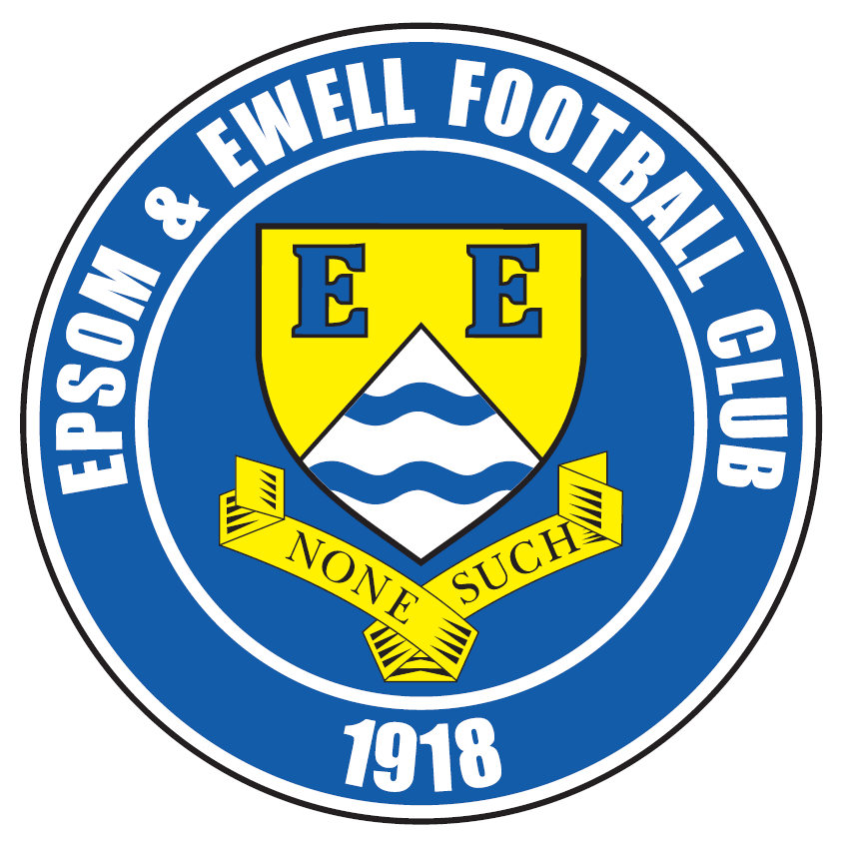 | Epsom & Ewell F.C.  9  v  Chertsey Town  Saturday, 17th October 2015
Good afternoon! We welcome the players, supporters and officials of Chertsey Town for this League match, together with today’s match officials and of course our regular faces.

Our opponents are frequent visitors and a full article on this will follow further on in today’s issue. Last season we both won our away match with neither being short on controversy. Back in October we were defeated 2-1 despite the visitors finishing with nine men, while in the return we reversed the score line, but suffered our own player shortage after Daryl Cooper-Smith was sent off.

Last time we were at High Road we witnessed a nervy but ultimately successful 1-0 win over Farnham Town. There were of course two talking points from this match, both good and bad. The good bit was the fantastic overhead kick goal from Matt Ferdinando that may actually have been the best goal I’ve ever seen from an Epsom player. The bad news was the controversial decision to send Craig Hastings off after 28 minutes, when a better application of the advantage law would have seen their man go through to equalise and ours would have remained on the pitch. He was suspended for our League Cup trip to Banstead but is back in consideration for a place today.

The report from the Farnham Town match has been compiled by our new Saturday home matchday reporter Sam Brooker who is a pupil at Glyn School. I hope you’ll make him welcome!

Seven days later we travelled to Cove where I had to consult the history books. Our 7-0 win there was the first time we had scored seven times away from home in a League match since our club record 9-0 win at Whyteleafe in April 1975 and had the added bonus of putting us top of the table. Kyle Hough scored a fantastic hat trick with a little bit of magic sprinkled over all three, while Rob Hendry scored two goals from distance and will have been kicking himself for not scoring his own hat trick, having two good chances at the end that were easier than the ones he scored from!

We then had ten days off, following the rearrangement of our trip to Hartley Wintney before taking on Banstead Athletic in the League Cup and we had a major scare, requiring penalties to progress after looking completely in charge at half time. Hopefully the many injuries sustained are not serious and that the players will be fit and well to take their place today.

Our next match is here on Tuesday when we host Ryman League new boys Dorking Wanderers in the Surrey Senior Cup. They are having a good season, so it will be interesting to see how we get on. Following that, on the Saturday we travel to Ashford Town for a tough looking League battle, and with the League Cup having now paired us together, this becomes a really pivotal fixture.

Enjoy the game!

Rich

Check us out on Facebook www.facebook.com/epsomandewellfc or on Twitter @EEFCOfficial

Today’s cover commemorates 125 years since football began at West Street

- A picture of West Street in the early nineties, just before we had to leave
- A picture of the clubhouse at West Street from that same period
- An 1890s team photo of Ewell F.C. the first team to use West Street


Cherry Red Records Combined Counties League
Premier Division Table 2015/16
inc Tuesday 13th October | P | W | D | L | F | A | Pts | GD | H | A
Ashford Town (Mx) | 13 | 10 | 0 | 3 | 30 | 16 | 30 | +14 | 30/4 | 24/10
Camberley Town | 12 | 8 | 3 | 1 | 19 | 10 | 27 | +9 | 16/4 | 20/2
Epsom & Ewell | 10 | 7 | 3 | 0 | 26 | 8 | 24 | +18 | X | X
Horley Town | 11 | 7 | 1 | 3 | 30 | 12 | 22 | +18 | 27/2 | 28/12
Hanworth Villa | 10 | 7 | 1 | 2 | 20 | 9 | 22 | +11 | 21/11 | 23/4
Hartley Wintney | 7 | 7 | 0 | 0 | 31 | 5 | 21 | +26 | 30/1 | 17/11
Raynes Park Vale | 11 | 6 | 0 | 5 | 28 | 24 | 18 | +4 | 3-1 | 28/3
Chessington & Hook | 11 | 5 | 2 | 4 | 22 | 18 | 17 | +4 | 7/11 | 19/3
Knaphill | 11 | 5 | 1 | 5 | 20 | 14 | 16 | +6 | 12/3 | 14/11
Colliers Wood United | 12 | 5 | 1 | 6 | 25 | 20 | 16 | +5 | 3-1 | 28/11
AFC Hayes | 11 | 5 | 1 | 5 | 13 | 13 | 16 | 0 | 1-1 | 9/1
Guildford City | 12 | 5 | 1 | 6 | 20 | 30 | 16 | -10 | 5/12 | 2/4
Windsor | 11 | 3 | 6 | 2 | 16 | 22 | 15 | -6 | 2-2 | 23/1
Spelthorne Sports | 12 | 4 | 2 | 6 | 19 | 25 | 14 | -16 | 16/1 | 6-2
Westfield | 10 | 3 | 4 | 3 | 11 | 12 | 13 | -1 | 26/3 | 0-0
Farnham Town | 9 | 3 | 1 | 5 | 16 | 13 | 10 | +3 | 1-0 | 6/2
Sutton Common Rovers | 11 | 3 | 1 | 7 | 21 | 29 | 10 | -8 | 19/12 | 2-1
Bedfont Sports | 8 | 1 | 4 | 3 | 11 | 12 | 7 | -1 | 13/2 | 24/11
Badshot Lea | 11 | 2 | 1 | 8 | 15 | 36 | 7 | -21 | 9/4 | 12/12
Chertsey Town | 11 | 1 | 3 | 7 | 8 | 19 | 6 | -11 | 17/10 | 5/3
Redhill | 11 | 1 | 2 | 8 | 13 | 30 | 5 | -17 | 2/1 | 1-0
Cove | 11 | 1 | 0 | 10 | 6 | 43 | 3 | -37 | 8/12 | 7-0

Lucky Day? – 17th October
Played 12 - W 7 D 1 L 4 - F 25 A 15 - PPG 1.83 - Good
Our Club record against Chertsey Town
Played 45 - W 16 D 5 L 24 - F 65 A 82 - PPG 1.18 - Below Average
Largest wins and losses
7th September 2002, 12th April 2003, 8th December 2009 - Won 3-0 - League x2 & SSC -- 20th March 2012 - Lost 0-7 - Associate Members Trophy QF
Last visit
Tuesday 28th October 2014 - Lost 1-2 - Combined Counties League

Club Manager - Glyn Mandeville
Good afternoon everyone. I would like to welcome players staff and supporters of Chertsey Town to today's game.

This will be a tough afternoon for us but hopefully we can carry on with this very good run of late. We come into today's game in very good form with wins over Farnham and Cove, which I was not around for but would like to say a big thank you to Matt Smith, Mr McKay, Steve and Jimmy for their help.

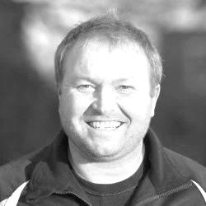
We played Banstead in the Cup on Tuesday and won on penalties 7-6. Not the best, but a win’s a win. Nights like that are when team spirit means a lot, and we worked very hard on a very tough night.

Hope you enjoy today’s game and have a safe trip home.

Manders

Club Captain - Sam Currie

Good afternoon and welcome to High Road for our fixture against Chertsey Town, where we will be looking to continue our impressive league run.

We welcome all the Chertsey players, coaching staff and travelling supporters and hope they have a safe journey home following the game.

Tuesday saw us advance in the League Cup against a tough Banstead side, who although a league below, offered us a stern test in what was a physical encounter against a local side - winning on penalties with big Mike in particular having a good game between the sticks.

We will be hoping that Jimmy the Club Physio will have patched up the squad following the game, to try and emulate the league performance from two weeks back at Cove, where on the day everything just seemed to click and we played what I thought was some of the best stuff the lads have produced all season.

Whilst being ruthless upfront, we were solid at the back and a clean sheet is always a nice feat.

So we hope you enjoy today's game and we can send the supporters home with a smile on their faces once again.

We look forward to seeing you again soon and thanks for the support both home and away.
Sam

Latest Results and Fixtures
Combined Counties League – Friday 25th September
Hanworth Villa | 1-0 | Knaphill
Emirates F.A. Cup – Second Qualifying Round – Saturday 26th September
Merthyr Town | 0-1 | Hartley Wintney
Combined Counties League – Saturday 26th September
AFC Hayes | 1-0 | Horley Town
Badshot Lea | 2-1 | Chertsey Town
Chessington & Hook United | 4-1 | Cove
Epsom & Ewell | 1-0 | Farnham Town
Guildford City | 0-4 | Colliers Wood United
Redhill | 1-3 | Raynes Park Vale
Spelthorne Sports | 5-2 | Sutton Common Rovers
Westfield | 3-2 | Ashford Town (Mx)
Windsor | 0-0 | Camberley Town
Combined Counties League – Tuesday 29th September
Chertsey Town | 0-3 | Hanworth Villa
Hartley Wintney | 2-0 | Ashford Town (Mx)
Redhill | 3-2 | Horley Town
Westfield | 0-1 | AFC Hayes
Combined Counties League Cup 1st Round – Friday 2nd October
Dorking Wanderers Reserves | 2-1 | South Park Reserves
F.A. Vase Second Qualifying Round – Saturday 3rd October
Beckenham Town | 2-0 | Redhill
Chertsey Town | 0-2 | Tadley Calleva
Cobham | 0-3 | Sutton Common Rovers
Cogenhoe United | 3-1 | AFC Hayes
Fairford Town | 4-2 | Badshot Lea
Hanworth Villa | 2-1 | Oxhey Jets
Hartley Wintney | 4-1 | Milton United
Knaphill | 3-1 | Lydney Town
Malmesbury Victoria | 2-2+ | Farnham Town
Farnham Town won 4-2 on penalties
Westfield | 1-2 | Carterton
Windsor | 2-1+ | Royal Wootton Bassett Town
Combined Counties League Cup 2nd Round – Saturday 3rd October
Worcester Park | 1-5 | Chessington & Hook United
Combined Counties League – Saturday 3rd October
Camberley Town | 2-1 | Ashford Town (Mx)
Latest Results and Fixtures
Combined Counties League – Saturday 3rd October
Colliers Wood United | 2-3 | Spelthorne Sports
Cove | 0-7 | Epsom & Ewell
Guildford City | 5-3 | Raynes Park Vale
Combined Counties League – Tuesday 6th October
Bedfont Sports | 2-3 | AFC Hayes
Horley Town | 6-0 | Windsor
Combined Counties League – Wednesday 7th October
Colliers Wood United | 1-2 | Ashford Town (Mx)
Emirates F.A. Cup – Third Qualifying Round – Saturday 10th October
Eastbourne Borough | 3-2 | Hartley Wintney
Combined Counties League Cup 2nd Round – Saturday 10th October
Sheerwater | 3-3+ | Frimley Green
Frimley Green won 8-7 on penalties
Combined Counties League – Saturday 10th October
AFC Hayes | 4-1 | Guildford City
Ashford Town (Mx) | 4-2 | Raynes Park Vale
Badshot Lea | 3-3 | Horley Town
Chertsey Town | 1-1 | Westfield
Colliers Wood United | 2-3 | Windsor
Farnham Town | 4-1 | Hanworth Villa
Knaphill | 1-2 | Camberley Town
Redhill | 2-2 | Bedfont Sports
Spelthorne Sports | 3-0 | Cove
Sutton Common Rovers | 6-0 | Chessington & Hook United
Combined Counties League Cup 2nd Round – Tuesday 13th October
AFC Hayes | 0-1 | Raynes Park Vale
Ashford Town (Mx) | 2-1 | Epsom Athletic
Badshot Lea | 2-4 | Spelthorne Sports
Banstead Athletic | 1-1+ | Epsom & Ewell
Epsom & Ewell won 7-6 on penalties
Bedfont & Feltham | 1-5 | Colliers Wood United
Camberley Town | 4-2 | Eversley & California
Cove | 1-6 | Cobham
Dorking | 0-3 | Knaphill
Farnham Town | 3-2 | Abbey Rangers
Hanworth Villa | 1-2+ | Chertsey Town
Hartley Wintney | 4-2 | Horley Town
Redhill | 3-0 | Sutton Common Rovers
Latest Results and Fixtures
Combined Counties League Cup 2nd Round – Tuesday 13th October
Westfield | 1-0 | CB Hounslow United
Combined Counties League – Saturday 17th October
Badshot Lea | V | AFC Hayes
Bedfont Sports | V | Ashford Town (Mx)
Chessington & Hook United | V | Knaphill
Cove | V | Redhill
Epsom & Ewell | V | Chertsey Town
Guildford City | V | Spelthorne Sports
Hanworth Villa | V | Camberley Town
Horley Town | V | Colliers Wood United
Raynes Park Vale | V | Hartley Wintney
Sutton Common Rovers | V | Farnham Town
Windsor | V | Westfield
Surrey Senior Cup 2nd Round – Tuesday 20th October
Camberley Town | V | Knaphill
Epsom & Ewell | V | Dorking Wanderers
Combined Counties League – Tuesday 20th October
Chessington & Hook United | V | Colliers Wood United
Raynes Park Vale | V | Farnham Town
Combined Counties League – Friday 23rd October
Hanworth Villa | V | Redhill
Combined Counties League – Saturday 24th October
AFC Hayes | V | Cove
Ashford Town (Mx) | V | Epsom & Ewell
Camberley Town | V | Sutton Common Rovers
Chertsey Town | V | Bedfont Sports
Chessington & Hook United | V | Guildford City
Colliers Wood United | V | Badshot Lea
Farnham Town | V | Windsor
Knaphill | V | Hartley Wintney
Spelthorne Sports | V | Horley Town
Westfield | V | Raynes Park Vale
Combined Counties League – Tuesday 27th October
AFC Hayes | V | Hartley Wintney
Chertsey Town | V | Raynes Park Vale
Chessington & Hook United | V | Bedfont Sports
Horley Town | V | Guildford City

First Eleven Appearances - (max 13 – including Banstead Athletic – 13/10/15)
Name | Debut | 2014/15 |  |  |  | Career Totals
Name | Debut | App | Sub | Total | Goals | App | Sub | Total | Goals
AJAYI Tayo | 22/08/2015 | 0 | 2 | 2 | 0 | 0 | 2 | 2 | 0
COOPER-SMITH Daryl | 03/01/2015 | 8 | 3 | 11 | 4 | 17 | 6 | 23 | 10
CURRIE Sam | 04/08/2012 | 12 | 1 | 13 | 0 | 120 | 10 | 130 | 2
DAVISON Conor | 22/08/2015 | 0 | 2 | 2 | 0 | 0 | 2 | 2 | 0
DEAN Dan | 02/08/2014 | 13 | 0 | 13 | 0 | 49 | 1 | 50 | 0
DEWAR Ali | 29/10/2011 | 0 | 0 | 0 | 0 | 55 | 35 | 90 | 10
EACOTT Michael | 02/08/2014 | 11 | 0 | 11 | 0 | 57 | 0 | 57 | 0
FARRELL Matt | 02/08/2014 | 12 | 0 | 12 | 3 | 53 | 3 | 56 | 10
FERDINANDO Matt | 20/09/2014 | 8 | 0 | 8 | 1 | 35 | 4 | 39 | 7
GRIFFIN Reisse | 08/08/2015 | 5 | 0 | 5 | 0 | 5 | 0 | 5 | 0
HASTINGS Craig | 08/08/2015 | 6 | 3 | 9 | 0 | 6 | 3 | 9 | 0
HENDRY Rob | 08/08/2015 | 12 | 1 | 13 | 5 | 12 | 1 | 13 | 5
HOUGH Kyle | 14/08/2007 | 11 | 0 | 11 | 10 | 307 | 15 | 322 | 181
KURDZIEL Jakub | 29/08/2015 | 1 | 0 | 1 | 0 | 21 | 0 | 21 | 0
MARVELL Dale | 15/01/2000 | 1 | 0 | 1 | 0 | 1 | 0 | 1 | 0
MCGREGOR Alex | 08/08/2009 | 7 | 4 | 11 | 1 | 268 | 49 | 317 | 86
MCKAY Alex | 20/12/2008 | 6 | 2 | 8 | 2 | 178 | 58 | 236 | 29
NEALE Thomas | 13/10/2015 | 6 | 1 | 7 | 0 | 91 | 27 | 118 | 8
NEILL David | 03/10/2015 | 0 | 1 | 1 | 0 | 0 | 1 | 1 | 0
NORTH Rhys | 16/08/2015 | 1 | 1 | 2 | 0 | 1 | 1 | 2 | 0
OLIVER Beckett | 29/08/2015 | 1 | 5 | 6 | 0 | 1 | 5 | 6 | 0
PANAYIOTOU Savvas | 03/01/2015 | 2 | 3 | 5 | 0 | 2 | 3 | 5 | 0
SMITH Matt | 08/08/2009 | 2 | 0 | 2 | 0 | 18 | 3 | 21 | 3
TANTON Matt | 02/08/2014 | 0 | 0 | 0 | 0 | 91 | 43 | 134 | 10
TAYLOR James | 26/08/2013 | 10 | 0 | 10 | 0 | 28 | 4 | 32 | 1
Own Goal |  |  |  |  |  |  |  |  | 1

Match Report by Sam Brooker
Epsom & Ewell 1-0 Farnham Town
Combined Counties League Premier Division - Saturday 26th September 2015

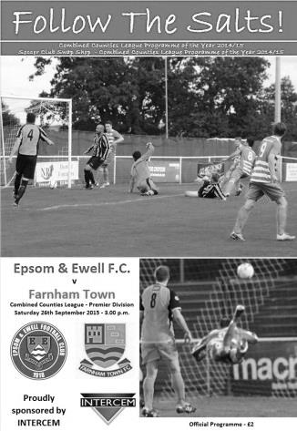
Ferdinando wonder goal wins all three points for the Salts

Farnham Town ventured to our shared ground at Chipstead to compete in - what transpired to be - an exhilarating fixture.

In terms of personnel we were still missing our leading scorer Kyle Hough, while Michael Eacott was working so we were able to sign former keeper Adrian Jones to fill the gap. At the back, Captain Sam Currie returned to the starting line up along with the fit again Matt Ferdinando and they took the places of James Taylor and Dale Marvell respectively. Ferdinando in particular would have a very impressive day.

The match initiated at a blistering intensity with the back four doing a tremendous job of tranquilizing the havoc, thus providing excellent stability for the midfield maestros to orchestrate the play. This was particularly prevalent in the early stages of the match, as we won a free kick in the opening minutes but were, unfortunately, unable to capitalise.

Besides a solitary but dangerous break by Farnham (which was caught offside), The Salts dominated all of the early pressure. Farnham’s Matt Glass caused several issues down the right flank, although, nothing beyond the defensive capabilities of Matt Tanton and Craig Hastings. Glass was aided by the Farnham full backs, firing in some perilous crosses which were fortunately dealt with by our esteemed centre backs. Our own full backs then burst into life and followed suit, skilfully rolling the ball into promising areas, however, possibly due to the lack of our resident striker (Hough), there was no one lurking in proximity in order to capitalise. The opening shot at goal came from Farnham in the form of a free kick marginally outside of the box, which Jones comfortably and confidently dealt with, calming the nerves of spectators and players alike.

Epsom wasted no time in responding, executing an efficient break on the left, which forced Lee Marker to race off of his line and battle against Daryl Cooper-Smith, the latter won the ball and shifted it to Rob Hendry who then found Matt Farrell who was free to float a delicious delivery into the box that was spectacularly dispatched into the top right hand corner via an athletic overhead kick from Ferdinando in the 9th minute - a goal that would be celebrated even in the top flight of Football.

Epsom continued the game in the same vein, with a similar chance coming only minutes later; unfortunately, the same heroics could not be emulated so the chance went begging. Epsom manipulated the width of the pitch beautifully; the flaw with this was that we were occasionally being caught out by Farnham’s pressure on the ball and one accurate pass was enough to expose our back four.

In the attacking half, we exhibited an abundance of trickery and skill, however, we lacked aerial threat and as a result, were prevented from extending the 1-0 lead. Epsom’s confidence grew as the first half progressed, as demonstrated by the cool temperaments of Matt Tanton and Daryl
Cooper-Smith when under pressure, who managed not only managed to win the ball back but also

put the home side back on the offensive.

Farnham’s 20th minute substitution didn’t affect the run of play as Epsom continued to retain possession and advance up the pitch. However, the second goal remained elusive as Epsom and Ewell began to break down in the final third. A corner from the away side then caused trouble, it was whipped into the heart of the 6 yard box and amidst the havoc, the ball was almost turned into the net. Luckily, it was scrambled clear by some disjointed defending. Ferdinando then redeemed the home side by executing a damaging run through the centre of Farnham’s defence before sliding a selfless pass to his right, the return was poor and another chance was extinguished. Epsom immediately launched another attack, this time opting for incisive, one touch passes, which preceded a drilled cross across the face of the goal for a goal kick, the slightest of contact could have been enough to double the lead.

The equaliser would have come in the form of a long pass neatly controlled by Glass who was almost brought down on the edge of the box, but still managed to slot the ball beyond Jones. The referee was instantaneous in blowing his whistle - playing advantage must have slipped his mind - and issued a red card in the 28th minute to Hastings. Many regular supporters were outraged at the time, but considering the final score this may have come as a blessing in disguise as the clever free kick was blazed over the bar. We were however, a man down and at the mercy of their energetic forwards.

Now the pendulum swung in favour of Farnham, their tails were up and after a series of crosses and corners that were tentatively dealt with by our boys, one couldn’t help but feel it was Farnham’s mistakes as opposed to Epsom’s defence that maintained the lead. In the same way as the home side, the visitors experienced a dearth of aerial threat and runners in behind during their period of dominance. They had plenty of chances but, fortunately, their finishing was more erratic than that of their opposition.

The relentless pressure eventually subsided and a free kick from Epsom and Ewell brought balance back to the game, the contact wasn’t there to direct the low cross and a deep corner was almost converted as Dan Dean’s low volley was blocked on the line by Matt Graham. In addition, Alex McKay neutralised the pace of Glass well to keep him under wraps. Moments before the culmination of the first half, Epsom sent in an excellent corner which stimulated chaos in the Farnham box. As had been the theme throughout the half, it wasn’t put away as we seemed determined to score only with sensational efforts rather than traditional methods - to the credit of Farnham’s defence.

The second half began evenly, team talks appeared to have centred around structure and defensive positioning as both teams were nullifying attacks far more effectively. The match had elevated in terms of physicality, evidenced by Cooper-Smith being bundled to the ground by Sean Evans on two occasions following some testing long balls. Our intentions were evident as Fernando narrowly missed with an effort from range.

Farnham’s speed continued to pose a threat but they struggled to create any clear opportunities from their attacking endeavours. At this point, we made their first substitution: James Taylor came on for Alex McGregor in the 60th minute. A wayward ball from Evans illustrated the difference between the two sides, Epsom, despite a few errors, executed greater precision in order to dissect the defence and deserved their 1-0 lead. Cooper-Smith had now settled into his role and found himself in intelligent positions twice in quick succession, and he was brought down on both occasions, the former in a legally questionable fashion one might argue. This was succeeded by another home substitution: Beckett Oliver replaced Ferdinando in the 70th minute.

There was no respite of excitement as McKay bundled a corner into the goal before being accused of impeding the goalkeeper and another goal being disallowed. The clock ticked down to 16

minutes remaining and the anxiety of the players grew as McKay made his presence felt in Farnham’s 6-yard box before voicing his frustrations (on behalf of the team) as he was blown up again for a foul on the goalkeeper.

Farnham began peppering the home defence with deliveries from all areas of the pitch but we held firm and allowed them little room to manoeuvre. A late decision went against Tanton, entering him into the referee’s book in the 93rd minute and provided the visitors with a chance from beyond the box on the right flank, an in swinging delivery was headed narrowly wide, Farnham persisted with some menacing attacks which were courageously blocked and deflected by Epsom for long enough to crawl over the line…Victorious.

Controversy shrouded the referee but he was consistent despite the onslaught from both players and spectators. Last season we experienced a record eleven red cards and are already on two this season, so we’re no strangers to playing with ten men but there’s definitely a lesson to be learned there, luckily it didn’t cost us this time.

Team: Adrian Jones, Sam Currie ©, Matt Tanton, Craig Hastings, Dan Dean, Alex McKay, Alex McGregor, Matt Farrell, Robert Hendry, Daryl Cooper-Smith, Matt Ferdinando.

Subs: James Taylor for Alex McGregor (60), Beckett Oliver for Ferdinando (70), Dale Marvell for Hendry (81).

Player Profile – Number 6 – Craig Hastings
Our latest player profile is from Craig Hastings.

Craig joined us this season from Cheam and has settled in at the back well, making a number of appearances, although had to sit out the Banstead game after being sent off at Farnham. However, he is back in consideration for a place today.

Age: 29

Position: Central Defender

Club supported: Manchester United

Favourite Food: Thai

Favourite Film: The Business

Messi or Ronaldo: Messi

Favourite Drink: Peroni

Favourite Ground played at: Upton Park, West Ham United

Best moment for Epsom: Signing for the club!

Describe the Gaffa in three words: Dry – Good Looking – Slim
(OK, that’s four words (club fine?) but we’ll move on!)

Craig’s Playing Stats: Debut 08/08/15 - Total Appearances: 9

Combined Counties League Premier Division Opponents
All-time Records
incl Tuesday 13th October | P | W | D | L | F | A | PPG | GD | Best  Win | Worst  Loss
Spelthorne Sports* | 4 | 3 | 1 | 0 | 13 | 5 | 2.50 | +8 | 6-2 | -
Sutton Common Rovers | 9 | 7 | 1 | 1 | 24 | 11 | 2.44 | +13 | 4-0 | 1-4
Horley Town | 26 | 19 | 4 | 3 | 57 | 24 | 2.35 | +33 | 6-0 | 1-3
Knaphill | 4 | 3 | 0 | 1 | 10 | 6 | 2.25 | +4 | 4-1 | 1-2
Westfield | 17 | 11 | 3 | 3 | 39 | 27 | 2.12 | +12 | 6-1 | 0-4
Colliers Wood United | 19 | 12 | 2 | 5 | 39 | 27 | 2.00 | +12 | 4-0 | 0-3
Bedfont Sports | 7 | 4 | 1 | 2 | 10 | 8 | 1.86 | +2 | 3-0 | 0-4
Hartley Wintney | 8 | 4 | 2 | 2 | 22 | 13 | 1.75 | +9 | 5-0 | 2-4
Farnham Town | 12 | 6 | 2 | 4 | 21 | 21 | 1.67 | 0 | 3-1 | 1-4
Raynes Park Vale | 25 | 12 | 5 | 8 | 54 | 36 | 1.64 | +18 | 6-1 | 0-2
Camberley Town* | 86 | 38 | 20 | 27 | 155 | 119 | 1.56 | +36 | 9-1 | 0-4
Cove | 33 | 14 | 9 | 10 | 74 | 55 | 1.55 | +19 | 7-0 | 1-6
Chessington & Hook | 26 | 10 | 9 | 7 | 51 | 41 | 1.50 | +10 | 6-0 | 1-3
Hanworth Villa | 12 | 5 | 3 | 4 | 26 | 22 | 1.50 | +4 | 5-2 | 1-4
Windsor | 46 | 18 | 12 | 16 | 86 | 86 | 1.43 | 0 | 4-0 | 0-6
Guildford City | 16 | 7 | 1 | 8 | 25 | 30 | 1.38 | -5 | 4-0 | 0-5
Redhill | 32 | 13 | 2 | 17 | 60 | 69 | 1.28 | -9 | 7-2 | 2-8
Badshot Lea | 15 | 5 | 3 | 7 | 26 | 32 | 1.20 | -6 | 3-0 | 0-4
Chertsey Town | 45 | 16 | 5 | 24 | 65 | 82 | 1.18 | -17 | 3-0 | 0-7
Ashford Town (Mx) | 15 | 3 | 2 | 10 | 19 | 39 | 0.73 | -20 | 3-0 | 0-5
AFC Hayes | 7 | 1 | 2 | 4 | 9 | 15 | 0.71 | -6 | 3-1 | 0-3
Grand Total | 476 | 220 | 91 | 164 | 896 | 772 | 1.58 | 124 | - | -
* includes one abandoned match v Camberley and one loss on penalties v Spelthorne
Glyn Mandeville – 50 not out!
It seems like only yesterday when we were appointing Glyn as our Manager, yet it was actually over a year ago, and here he is having already passed the fifty match milestone in charge of our club.

Our popular Manager had a playing career at Aldershot Town, Egham Town and Corinthian Casuals amongst others, and joined us during the 2010/11 season as one of Lyndon’s Coaching staff, following a few years as Manager of Bookham.

The two clubs had exchanged players quite frequently over the seasons before that, with players like Nathan Ayling, Alex McGregor, Mark Jarman, and more recently Sam Currie having represented both clubs so Glyn slotted straight in, becoming one of Lyndon Buckwell’s Assistant Managers alongside Tony Coombe for a couple of seasons, which culminated in our League Cup win of 2013 and him being Lyndon’s main Assistant from that point.

When Lyndon advised us of his intention to resign last September, it was an easy decision to ask Glyn to step up and he was more than happy to do it. Since that time, he and Assistant Matt Smith have done a really good job, taking us to a seventh place finish last season and putting us in a position to improve on this in 2015/16.

So to commemorate his achievement it is of course necessary to embarrass him here with various photos from his time at the club! Congratulations Manders!
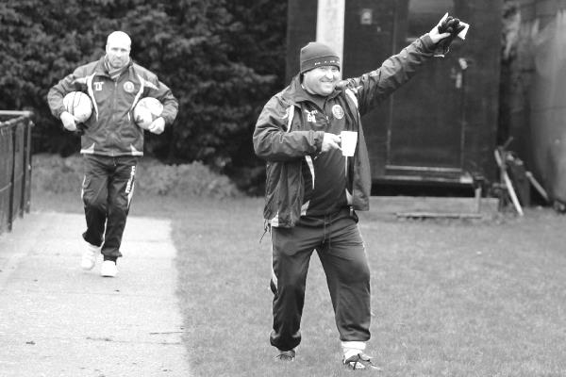

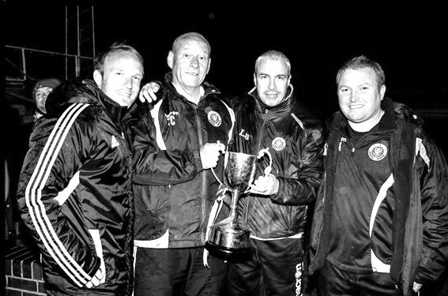

Glyn does like to pose for the camera sometimes!
Left: Glyn at Moatside for our home match with Dorking in January 2012
Above: Celebrating our League Cup win with the Management in May 2013
Below: Glyn’s debut for us at Frimley Green on 25th April 2015
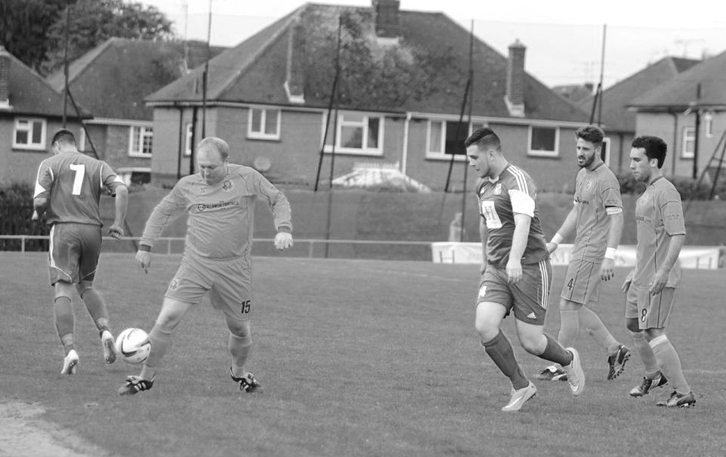

Club Records - 17th October
Date | Day | Competition |  | Opponents |  | Scorers
17/10/25 | Sat | Friendly | H | Casuals Reserves | 1-0 | F.Kent
17/10/31 | Sat | London League | H | Hendon | 7-1 | B.Williams (4), J.Williamson, B.Marlow (2)
17/10/36 | Sat | Friendly | H | Tottenham Hotspur XI | 2-1 | G.Collins, H.Pullen
17/10/53 | Sat | Amateur Cup 2q | A | Surbiton Town | 2-0 | B.Wiles (2)
17/10/59 | Sat | Surrey Senior Cup 2q | H | Worcester Park | 2-0 | S.Law, F.Vernon
17/10/64 | Sat | Athenian League Div 1 Cup 1 | H | Tilbury | 0-3
17/10/70 | Sat | Surrey Senior Cup 1q | H | Reigate Priory | 5-0 | J.Honeywood (3), A.Payne, K.Spears
17/10/78 | Tue | London Senior Cup 1q | A | St Albans City | 2-1 | T.McCready, J.Hunn
17/10/81 | Sat | F.A. Cup 3q | H | Hastings United | 2-4 | T.Tuite, J.Hunn (pen)
17/10/92 | Sat | Isthmian League 3 | H | East Thurrock United | 1-1 | G.Morris (pen)
17/10/93 | Sun | F.A. Vase  Preliminary Round replay | A | Ashford Town (Mx) | 1-3 | R.Purvis
17/10/09 | Sat | Combined Counties  Premier Division | H | Molesey | 0-1
Historical Decades
90 years ago – Epsom Town F.C.
17/10/25 | Sat | Friendly | H | Casuals Reserves | 1-0 | F.Kent
80 years ago – Epsom F.C.
12/10/35 | Sat | Amateur Cup 1q | H | Reigate Priory | 13-1 | H.Pullen (5), J.Jones (4), L.Green (2) L.Graves, o.g.
70 years ago – Epsom F.C.
13/10/45 | Sat | London League | A | Guildford City Reserves | 1-8 | R.Stanford
60 years ago – Epsom F.C.
15/10/55 | Sat | Amateur Cup 1q | A | Devas Institute | 1-1 | G.Cairns
50 years ago – Epsom & Ewell F.C.
16/10/65 | Sat | Athenian League 2 | H | Marlow | 4-0 | G.Glennister (2), B.Harding, o.g.
40 years ago – Epsom & Ewell F.C.
18/10/75 | Sat | Athenian League 2 | H | Hemel Hempstead F.C. | 1-0 | P.Butler
30 years ago – Epsom & Ewell F.C.
16/10/85 | Wed | Isthmian League Cup 1 | A | Ruislip Manor | 2-1+ | R.Lewis, P.Kemp
20 years ago – Epsom & Ewell F.C.
21/10/95 | Sat | Isthmian League 3 | H | Clapton | 2-1 | P.Meredith, A.Boxall
10 years ago – Epsom & Ewell F.C.
22/10/05 | Sat | Isthmian League 2 | A | Kingsbury Town | 0-1

History Corner – 17th October
80 years ago this week we produced our record victory!!

Reigate Priory is a fine club, full of tradition. They remain the oldest club in the County to this day and were so old that they used to play against our forerunners Ewell F.C. back in the early days of West Street. Ewell won the majority of games, most importantly a Surrey Charity Shield Semi Final replay by three goals to one in 1898, but by the time Epsom Town had come into existence, the Priory were substantially weaker still.

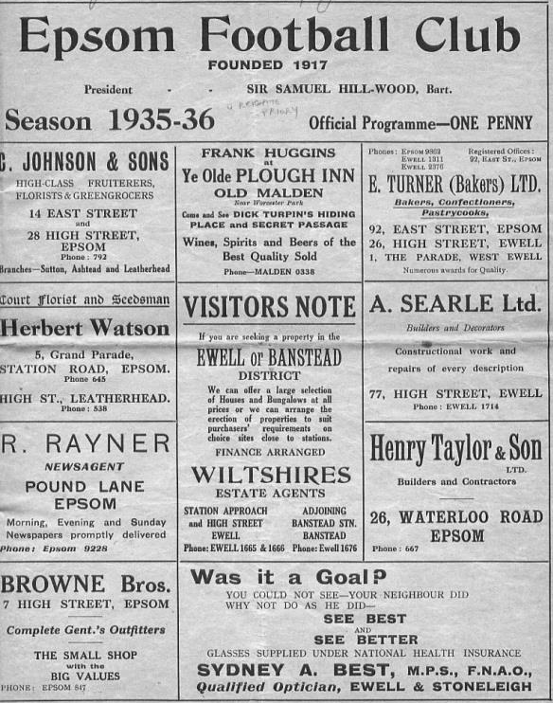
In fact, our club holds a perfect record against them with nine straight wins, going back to the Surrey Senior League days of the 1920s. As we moved up, our only meetings came in cup competitions and it was in the Amateur Cup that we drew them at West Street with inevitable carnage, bearing in mind the gulf between the sides. Two of our greatest goal scorers Jackie Pullen and Jimmy Jones scored nine between them as we registered a club record win of 13-1, leading 6-0 at the half and never letting up at any point. (see programme pictured).

Ironically one of our subsequent two meetings was on this very day in 1970 when we were in the middle of our worst ever season. To give an indication, we had lost our opening eleven League matches of the season, yet still defeated Reigate Priory 5-0 with Jim Honeywood scoring a hat trick on his debut!

84 years ago today we defeated Hendon 7-1 in a London League match. However, this is not the Hendon you may be thinking of, as that club, the more famous of the two, were originally known as Hampstead Town before changing to Golders Green and then Hendon just after the war, by which time, this smaller side were long gone. They played at the Welsh Harp Ground which is an open space still in existence, near to Kingsbury Reservoir in North West London. In this match Billy Williams, a former Schoolboy International and former professional at West Ham United would continue his fine run of form with four of the seven goals this day and would go on to get 41 in just 26 appearances this season. Who knows how many more he could have scored this season, but because he was a “permit player” he was not allowed to play in competitions like the Amateur Cup.

34 years ago today – one small indulgence – we were defeated 2-4 by Hastings United in the Third Qualifying Round of the F.A. Cup, despite leading 2-1 at half time. The main reason this match is here is because it was my first ever Epsom & Ewell match. Over 1,700 matches later, I still have very clear memories about my first ever visit to West Street and this is covered later in the issue.

22 years ago today we were forced into playing an F.A. Vase replay at Ashford Town (Mx) on a Sunday, despite having played and beaten Cove 5-2 on the Saturday! The last thing we needed was extra time and we went under 3-1 after holding them at 1-1 for the ninety minutes.

Looking Up
Ryman League Division One South Table
incl Wednesday 14th October | P | W | D | L | F | A | Pts | GD
Folkestone Invicta | 12 | 10 | 1 | 1 | 25 | 8 | 31 | +17
Corinthian-Casuals | 14 | 9 | 1 | 4 | 24 | 15 | 28 | +9
Molesey | 14 | 8 | 2 | 4 | 29 | 19 | 26 | +10
Ramsgate | 15 | 8 | 2 | 5 | 26 | 20 | 26 | +6
Dorking Wanderers | 14 | 7 | 4 | 3 | 30 | 16 | 25 | +14
Three Bridges | 14 | 7 | 2 | 5 | 20 | 17 | 23 | +3
South Park | 11 | 7 | 1 | 3 | 17 | 9 | 22 | +8
Worthing | 11 | 7 | 0 | 4 | 21 | 16 | 21 | +5
Herne Bay | 12 | 5 | 5 | 2 | 18 | 13 | 20 | +5
Faversham Town | 13 | 6 | 2 | 5 | 14 | 10 | 20 | +4
Walton & Hersham | 13 | 6 | 2 | 5 | 21 | 23 | 20 | -2
Walton Casuals | 14 | 6 | 1 | 7 | 23 | 26 | 19 | -3
Carshalton Athletic | 13 | 6 | 1 | 6 | 18 | 21 | 19 | -3
Peacehaven & Telscombe | 16 | 5 | 4 | 7 | 16 | 25 | 19 | -9
Sittingbourne | 12 | 6 | 0 | 6 | 20 | 19 | 18 | +1
Tooting & Mitcham United | 13 | 6 | 0 | 7 | 15 | 17 | 18 | -2
Guernsey | 11 | 5 | 2 | 4 | 23 | 17 | 17 | +6
Whyteleafe | 14 | 5 | 1 | 8 | 14 | 20 | 16 | -6
Hastings United | 10 | 5 | 0 | 5 | 19 | 14 | 15 | +5
Hythe Town | 14 | 3 | 4 | 7 | 10 | 19 | 13 | -9
Chatham Town | 13 | 3 | 3 | 7 | 16 | 19 | 12 | -3
Whitstable Town | 14 | 2 | 1 | 11 | 17 | 35 | 7 | -18
East Grinstead Town | 10 | 1 | 3 | 6 | 7 | 16 | 6 | -9
Chipstead | 13 | 0 | 2 | 11 | 6 | 35 | 2 | -29
Unusually, I shall start at the bottom of the table, as I’m sure that most of you would be looking for Chipstead first, now under the stewardship of our former Manager Lyndon Buckwell. Under his tenure they have doubled their points tally, but that’s not nearly enough yet, although they did record a fine F.A. Trophy win over Uxbridge who had beaten Conference National side Dartford seven days previously. There is of course plenty of time for them to pick up points.

At the top we see Folkestone Invicta again; a side that have been around the top spots for a few seasons now. Around them are some surprises though, not least Corinthian Casuals, whilst new boys Dorking Wanderers and Molesey are both coping well with their new opponents. Just below them and with games in hand are South Park and Worthing who I believe will still be very much involved by the end of the season.

Other teams looking over their shoulders include Whitstable, East Grinstead and Hythe Town and it is incredible that so few Kent based sides get relegated, leading to this rather odd imbalance in the divisions which sees teams like Phoenix Sports placed in the Northern Division, despite being south of the river! Of course the two Waltons ought to have been moved into the Southern League but call me cynical; it might have something to do with the long running sponsorship from Rymans, whose owner, one Theo Paphitis, is connected with the team from Stompond Lane!

Looking Up
Evo-Stik Southern League Central Division Table
incl Tuesday 13th October | P | W | D | L | F | A | Pts | GD
Royston Town | 11 | 7 | 1 | 3 | 27 | 12 | 22 | +15
St Ives Town | 11 | 6 | 4 | 1 | 21 | 10 | 22 | +11
Chalfont St Peter | 11 | 7 | 0 | 4 | 27 | 20 | 21 | +7
Ware | 11 | 6 | 2 | 3 | 18 | 15 | 20 | +3
Kings Langley | 10 | 6 | 1 | 3 | 16 | 11 | 19 | +5
Egham Town | 10 | 6 | 0 | 4 | 24 | 8 | 18 | +16
AFC Rushden & Diamonds | 8 | 5 | 3 | 0 | 15 | 7 | 18 | +8
Aylesbury | 11 | 5 | 3 | 3 | 17 | 13 | 18 | +4
Beaconsfield SYCOB | 11 | 5 | 2 | 4 | 23 | 16 | 17 | +7
Potters Bar Town | 10 | 5 | 2 | 3 | 14 | 15 | 17 | -1
Northwood | 10 | 5 | 1 | 4 | 17 | 16 | 16 | +1
Bedford Town | 10 | 4 | 1 | 5 | 14 | 14 | 13 | 0
Godalming Town | 10 | 3 | 3 | 4 | 11 | 12 | 12 | -1
Barton Rovers | 9 | 2 | 5 | 2 | 14 | 11 | 11 | +3
Uxbridge | 9 | 3 | 2 | 4 | 15 | 20 | 11 | -5
Fleet Town | 8 | 2 | 3 | 3 | 14 | 17 | 9 | -3
Hanwell Town | 9 | 2 | 3 | 4 | 10 | 15 | 9 | -5
North Greenford United | 11 | 2 | 2 | 7 | 16 | 26 | 8 | -10
Aylesbury United | 11 | 2 | 2 | 7 | 13 | 24 | 8 | -11
Leighton Town | 11 | 2 | 2 | 7 | 11 | 24 | 8 | -13
Arlesey Town | 11 | 2 | 1 | 8 | 9 | 29 | 7 | -20
Petersfield Town | 9 | 1 | 3 | 5 | 11 | 22 | 6 | -11
Seeing as Chertsey Town are our opponents this afternoon it makes sense to include this table too, as when the Curfews went up a few years back they found themselves as members of this division instead of the Ryman South that we would be moved into.

This division is filled with teams we have played over the last couple of decades from Royston Town at the top to Petersfield Town at the bottom, but the two sides to watch here may well be Egham Town, under the Management of our former player Gary Meakin and the unbeaten AFC Rushden and Diamonds, working their way up from their starting position of Step Six after the original Football League club folded.

Bearing in mind the recent allocations of both Hereford United and Salisbury into Step Five this does look particularly harsh, but they are back now and are well in the mix for a move up to Step Three at this rate.

I have been intrigued by the progress of Petersfield Town, who are covered in today’s A-Z section. They used to be the whipping boys when we met but I suppose that was 25 years ago and they will be fairly happy with their lot, despite the league position as they have defeated Weymouth and Cirencester Town, both of whom are Premier Division opponents in the F.A. Cup this season.

Looking Down
Combined Counties League Division One Table
incl Tuesday 13th October | P | W | D | L | F | A | Pts | GD
Eversley & California | 10 | 8 | 0 | 2 | 32 | 12 | 24 | +20
CB Hounslow United | 9 | 8 | 0 | 1 | 21 | 5 | 24 | +16
Worcester Park | 9 | 6 | 1 | 2 | 23 | 10 | 19 | +13
Staines Lammas | 10 | 5 | 1 | 4 | 24 | 14 | 16 | +10
Abbey Rangers | 9 | 5 | 1 | 3 | 15 | 11 | 16 | +4
Bedfont & Feltham | 5 | 5 | 0 | 0 | 20 | 5 | 15 | +15
Sandhurst Town | 9 | 4 | 2 | 3 | 17 | 20 | 14 | -3
Cobham | 9 | 4 | 1 | 4 | 21 | 21 | 13 | 0
Frimley Green | 6 | 4 | 0 | 2 | 9 | 8 | 12 | +1
Dorking | 9 | 4 | 0 | 5 | 15 | 15 | 12 | 0
Epsom Athletic | 10 | 4 | 0 | 6 | 21 | 33 | 12 | -12
Banstead Athletic | 8 | 2 | 2 | 4 | 12 | 18 | 8 | -6
Sheerwater | 8 | 2 | 1 | 5 | 11 | 18 | 7 | -7
Dorking Wanderers Reserves | 9 | 2 | 1 | 6 | 10 | 20 | 7 | -10
Farleigh Rovers | 9 | 2 | 0 | 7 | 8 | 28 | 6 | -20
Ash United | 8 | 1 | 2 | 5 | 13 | 21 | 5 | -8
South Park Reserves | 9 | 1 | 0 | 8 | 11 | 24 | 3 | -13
It is early days in most leagues but for the division below us, some have already completed a third of their fixtures and we see the age old chestnut here, which is better, points on the board or games in hand? I suppose the answer lies in how many points a club actually has, or indeed, how many games a club has in hand!

So with that in mind, who is favourite? Right now Eversley & California look as though they might finally be able to secure the promotion that they were denied a season ago, but nine points behind them are Bedfont & Feltham who have a 100% record and five games in hand in which to achieve them. At the same time it is hard to ignore the upturn in form from CB Hounslow United this season who have really struggled for the last couple of seasons but with the progress on their new ground likely to come to fruition shortly, they have clearly decided that the time is right for a league push.

In a traditionally very tight division, these three clubs have laid down a marker and right now the only other clubs that might threaten do not have the ground grading. Worcester Park and Staines Lammas have just this season to get to grips with their position as the F.A. will surely finally enforce their relegation deadline in May, even though they haven’t done it previously. Abbey Rangers are fine for Step Six but I am not sure what work they would need to do to move up in their first season.

Finally, I shall finish with Dorking who have endured a torrid recent few years and are currently sharing at Horley Town. I popped in to their old ground at Meadowbank to get some pictures as the stand side of the ground is to be developed any day now into a super-duper £4.5m complex which will house both themselves and Dorking Wanderers, not to mention the Surrey F.A. Exciting times ahead maybe?

CCL Premier Division Club Directory
A.F.C. HAYES Telephone: 0208-845-0110 - Ground: Farm Park, Kingshill Avenue, Hayes, Middx. UB4 8DD - Colours: Blue and White Stripes/Blue/Blue

ASHFORD TOWN (Mx) Telephone: 01784-245908 - Ground: The Robert Parker Stadium, Short Lane, Stanwell, Middx. TW19 7BH - Colours: Tangerine & White Stripes/Black/Tangerine

BADSHOT LEA Telephone: 01252-320385 - Ground: Ash United FC, Shawfield Stadium, Youngs Drive, Shawfields Road, Ash, Hampshire. GU12 6RE - Colours: Claret/White/Claret

BEDFONT SPORTS Telephone: 0208-831-9067 - Ground: Bedfont Sports Club, Hatton Road, Bedfont, Middx TW14 8JA - Colours: Red & Black Hoops/Black/Red & Black Hoops

CAMBERLEY TOWN Telephone: 01276-65392 - Ground: Krooner Park, Wilton Road, Camberley, Surrey. GU15 2QW - Colours: Red & White Stripes/Blue/Red

CHERTSEY TOWN Telephone: 01932-561774 - Ground: Alwyns Lane, Chertsey, Surrey. KT16 9DW - Colours: Royal Blue & White Stripes/Royal Blue/Royal Blue

CHESSINGTON & HOOK UNITED Telephone: 01372-602263 - Ground: Chalky Lane, Chessington, Surrey. KT9 2NF - Colours: Blue/Blue/Blue

COLLIERS WOOD UNITED Telephone: 0208-942 8062 - Ground: Wibbandune Sports Ground, Robin Hood Way, Wimbledon. SW20 0AA - Colours: Blue & Black Stripes/Black/Black

COVE Telephone: 01252-543615 - Ground: Oak Farm Fields, 7 Squirrel Lane, Cove, Farnborough, Hampshire. GU14 8PB - Colours: Yellow/Black/Yellow

EPSOM & EWELL Telephone: 01737-553250 - Ground: Chipstead FC, High Road, Chipstead, Surrey. CR5 3SF - Colours: Royal Blue & White Hoops/Royal Blue/Royal Blue & White Hoops

FARNHAM TOWN Telephone: 01252-715305 Ground: Memorial Ground, Babbs Mead, West Street, Farnham, Surrey. GU9 7DY Colours: - Claret & Sky Blue /White/ Claret & Sky Blue

GUILDFORD CITY Telephone: 01483-443322 - Ground: The Spectrum, Parkway, Guildford, Surrey. GU1 1UP - Colours: Red & White Stripes/Black/Black

HANWORTH VILLA Telephone: 0208-831-9391 - Ground: Rectory Meadows, Park Road, off Hounslow Road, Hanworth, Middlesex. TW13 6PN - Colours: Red & White Stripes/Black/Black

HARTLEY WINTNEY Telephone: 01252-843586 - Ground: Memorial Playing Fields, Green Lane, Hartley Wintney, Hants RG27 8DL - Colours: Orange & Black/ Orange /Orange

HORLEY TOWN Telephone: 01293-822000 - Ground: The New Defence, Anderson Way, Court Lodge Road, Horley, Surrey. RH6 8SP - Colours: Claret & Sky Blue/Claret/Claret

KNAPHILL Telephone: 01483-475150 - Ground: Brookwood Country Park, Redding Way, Lower Guildford Road, Knaphill, Surrey. GU21 2AY - Colours: Red/Black/Red

SUTTON COMMON ROVERS Telephone: 01932-866386 - Ground: Sutton United FC, Gander Green Lane, Sutton, Surrey SM1 2EY - Colours: Yellow/Black/Black

RAYNES PARK VALE Telephone: 020-8540-8843 - Ground: Prince Georges Playing Field, Grand Drive, Raynes Park, London. SW20 9NB - Colours: Blue/Blue/Red

REDHILL Telephone: 01737-762129 - Ground: Kiln Brow, Three Arch Road, Redhill, Surrey RH1 5AG - Colours: Red and White Stripes/Black/Red

SPELTHORNE SPORTS Telephone: 01932-961055 - Ground: Spelthorne Sports Club, 296 Staines Road, Ashford Common, Ashford, Middx. TW15 1RY - Colours: Light & Dark Blue/Dark Blue/Light Blue

WESTFIELD Telephone: 01483-771106 - Ground: Woking Park, Kingfield Road, Woking, Surrey. GU22 9BA - Colours: Yellow/Black/Black

WINDSOR Telephone: 01753-860656 - Ground: Stag Meadow, St Leonards Road, Windsor, Berks SL4 3DR - Colours: Red/Red/Red

125 years ago tomorrow!
On 18th October 1890 a new club played its first match. The club, Ewell F.C. would have a fair deal of success in its fifteen year existence and their founders were responsible for selecting and using a patch of ground to the side of Gibraltar Recreation Ground in Ewell to play their matches in. This exact site in West Street would of course be used by our own club some thirty five years later.

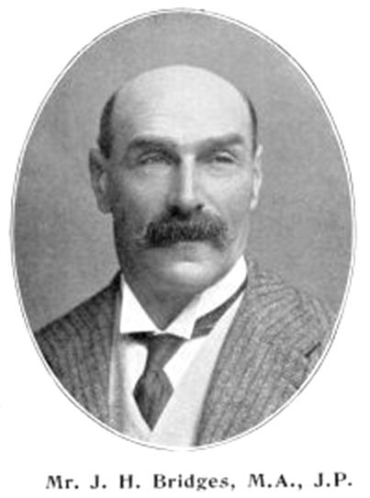
The Ewell club came into existence through the hard work of three main people. The first Chairman of the Club, which in those days was its President, John Henry Bridges, was born in Horsham on 26th March 1852 and lived in the Avenue House, off Kingston Road in Ewell, later renamed as Ewell Court House, where the library now stands, although much of the building is currently closed, following a major refurbishment after a fire there in December 2013. (picture below from 1912 taken by John Henry’s second wife Dorothy)

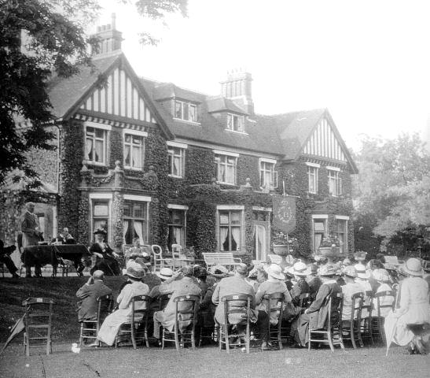
He was a Justice of the Peace but loved his sport and was a very fine archer, winning the British Open in 1905 and representing Great Britain at the 1908 Olympics, despite being 56 by that time! As a younger man he was a keen cricketer, playing twice for Surrey and regularly for Epsom C.C. at the same time as being Secretary and Treasurer of Ewell C.C.

In his cricket team were two local lads who were quite accomplished footballers. In fact, Arthur Melmoth Walters and Percy Melmoth Walters were as good as it got back then,

both being members of the Full England International team. They were the first brothers ever to play together for our Country, decades before the Charltons and latterly the Nevilles and were both defenders. Known by their initials they soon picked up the nicknames of Morning and Afternoon!

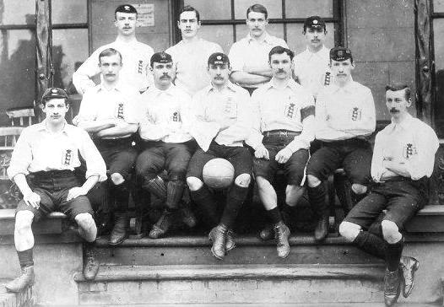
Arthur Walters is third from the left in the back row and Percy Walters in the centre of the front row as they lined up against Scotland at The Oval in 1889

Arthur was born in Ewell on 26th January 1865 and went to Cambridge University, while Percy (30th September 1863) went to Oxford University! Both had been at Charterhouse School and so were eligible to play for the Old Carthusians, while both also played for the most famous team of the Victorian era, The Corinthians. They also played for the earliest team known in our area, Epsom F.C. a short lived arrangement, based near Epsom Hospital’s current site from 1884-1886.

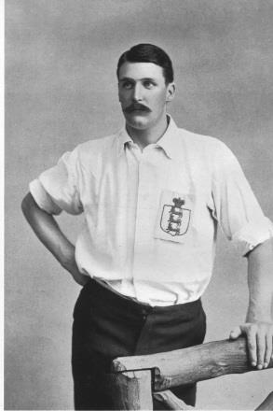
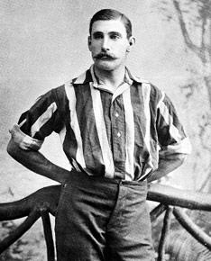
Of course in those days, the concept of “celebrity” was completely unknown and

during the Summer, when their law studies allowed, they would go and play cricket for their local team in their local park with no one batting an eyelid!

Their “local” was in Gibraltar Lane, now better known as West Street and although I am obviously unaware whether the brothers knew John Henry Bridges by then, they must have got around to talking football at some point. This then led to a foundation meeting at the Spring Hotel in Ewell High Street on Monday 6th October 1890 and within just twelve days they were playing their very first fixture; a 3-2 defeat to Barnes Reserves.

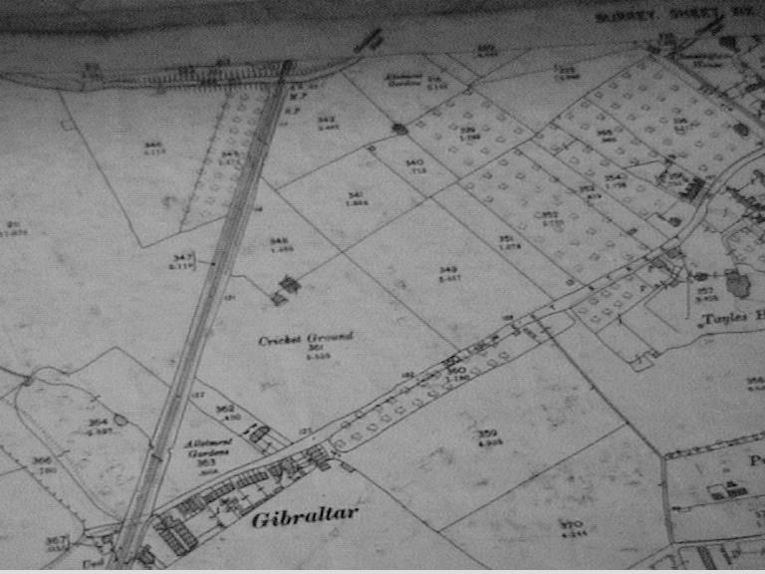

Finding a ground on which to play their home games appears to have been fairly straightforward and they chose the field adjacent to the cricket ground, shown as plot 349 on the above map, dated 1896.

Although I have no details of any match on 25th October, I can confirm that the most likely first ever match at West Street would have been when Ewell F.C. played Malden on the 1st November 1890, defeating them 3-1 with Arthur Walters scoring two goals in a more advanced role than he usually had, as Ewell retrieved a half time deficit. The other goal was scored by Hugh Melmoth Walters, a promising younger brother of the pair who was only 22 at the time and of whom great things were expected.

But fate was to play its tragic part as just eleven days later Hugh was seriously injured by a kick to the abdomen while playing for The Casuals at Wormwood Scrubs in front of the prison that was to open the following year, and although it was originally reported that he was out of danger, he then died of acute peritonitis on 27th November 1890.

The two brothers immediately retired from International football, never again pulling on the white England jerseys, and took a sabbatical from the game in its entirety for a while, although both returned to playing occasionally for Ewell and quite probably other teams the following season.

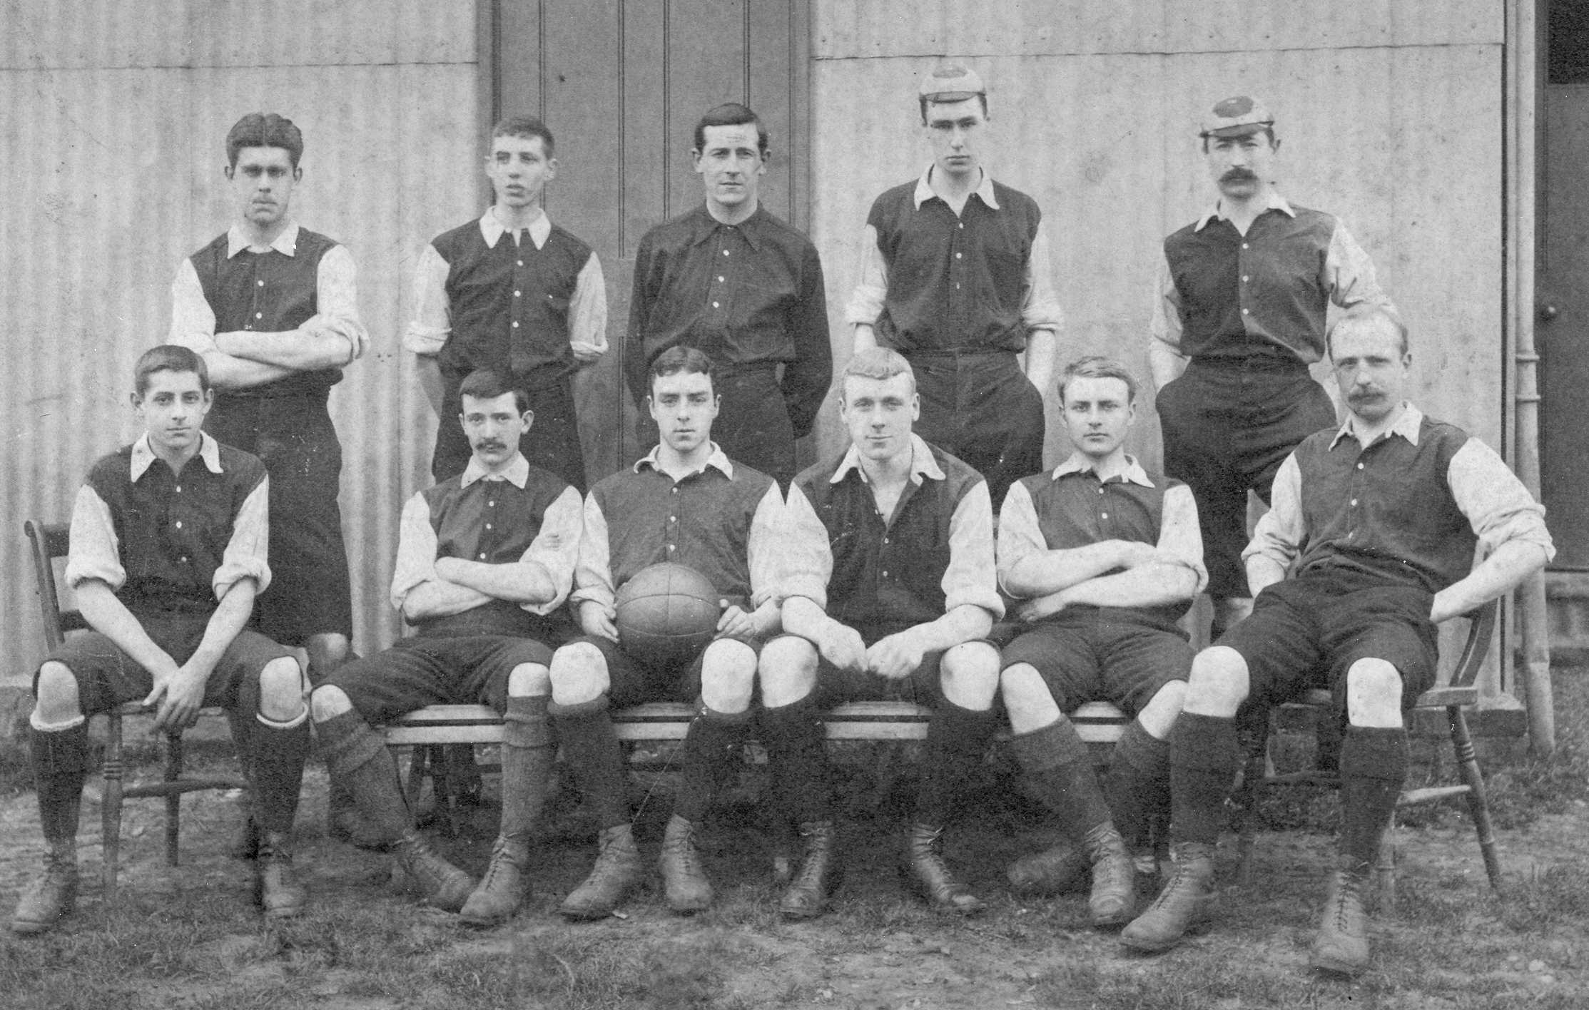
A picture of the Ewell side containing both Walters, Alex White and Barry Porter

The Ewell side were of Junior status at the time, so it was a little bit like Wayne Rooney kicking around with players in the Surrey Elite League; it must have been incredibly daunting for all that they faced, but of course they would often miss matches, as they still played in important matches for the Corinthians, Casuals and the Old Carthusians, leaving Ewell much weaker as a result. The club needed to stand on their own 22 feet!

Step forward Alexander Frederick White, born in Epsom in 1875. He lived at Ashley House in Ashley Road and was one of eight children. On his return from Aldenham Grammar School in Bushey, Hertfordshire in 1892, he got involved with his local team, as did his twin brother Felix Walter White, a talented left winger. Alex was an inside right, who could also play centre forward, and in his time at Ewell went on to score more goals at West Street than even Tommy Tuite would in more recent years!

Both he and his brother made their debuts in the first game of the 1892/93 season and despite their youth, they kept their places. In February of that season Alex scored eight goals in a 10-0 win at Whitgift School and he would remain at the club for the rest of its existence.

With players like this in the ranks, their progress was rapid and they won the Surrey Junior Cup on 3rd March 1894 by defeating Balham Wanderers by a score of 6-0 at Guildford F.C.’s Woodbridge Road ground. This score remains a record for the Final of this competition to this day with Alex White scoring two of the six, while the Perks brothers scored the rest; J.E. Perks getting a hat trick.

It should also be noted that the brothers Walters were not involved in any of the matches in this Cup run. In fact just one month later Arthur Walters was a playing member of the Old Carthusians team that would win the very first Amateur Cup Final with their 2-1 win over Casuals, with both brothers playing in the following year’s unsuccessful Final too. Despite their ages they were still dominant in their field.

Ewell promptly became a Senior status team and continued their attempts to become one of the best clubs in the County.

They were aided by another sixteen year old player by the name of Thomas Barron Porter, better known as Barry, who was born in 1878 and was a son of the famous racehorse trainer John Porter, (“undoubtedly the most successful trainer of the Victorian era”) who was the founder and Managing Director of Newbury Racecourse, where a race still exists in his name. He trained seven winners of the Derby and twenty-three of the “Classic” races in total. He only succeeded in creating Newbury racecourse in 1904 as a result of a chance meeting with Edward VII. How bizarre is that story!

Barry would soon carve out his own path, becoming an integral part of the team on the right wing and together with the Whites, playing numerous times for Surrey in the years to come.

The Ewell story went from strength to strength. They were already equipped to take on the best clubs in the country and with Porter now in their ranks the only way was up. In 1895 they reached the Semi-Final of the Surrey Senior Cup, losing 5-2 to West Croydon at the supposedly neutral venue of the Croydon Rugby Club! That season they also beat Dorking 11-0 at West Street and Reigate Priory 3-0 on their own patch, not bad for a first season!

Oddly, and despite entering the Surrey Senior Cup and Charity Shield, the club never entered the Amateur Cup, even though some of their founders had played such a prominent part in its first years. There is no reference to this in any of the A.G.M. minutes I have traced and I still don’t know why this was as they would have surely done quite well in it. The Surrey Herald would remark on it in 1899 but nothing further appeared to happen.

In 1895/96 they reached another Semi-Final, this time in the Surrey Charity Shield, although they were defeated again 2-0 to Guildford at Dorking’s Pixham Lane ground.

The following season they should have reached another Semi-Final but were robbed by West Norwood. Back in these days protests were frequent, especially in cup matches. The first match at High View Park, Norwood was played on a terrible surface and Ewell protested about it. The referee however, went ahead with the game and Ewell even led at half time through Alex White. However, after conceding twice early in the second half

they must have protested again as the referee stopped the game and decreed that it would be completed as a friendly. Arthur Walters was playing in this game and it is possible that his influence may have been used but we’ll never know. Anyway, the County F.A. agreed that the tie should be replayed back at Norwood, only for the tie to be postponed. Ewell were angry that they should have been notified of this before travelling but the match was rearranged for the following week with the caveat that if the pitch was still unplayable it would be moved to West Street, which in the end, it was.

Ewell then won the tie 3-1 in front of a crowd of 500 spectators only for the opposition to protest about the eligibility of Porter, who had recently moved from Surrey. Incredibly the S.C.F.A. then upheld the appeal and ordered the tie to be replayed once again back at West Norwood! Whether it was for this reason or not, Ewell then chose to withdraw from the competition at which point, their opponents protested again on the basis that Ewell had not scratched in time!! Fortunately this compensatory matter was settled but the clubs would never meet again.

In 1897/98 Ewell reached the Final of the Surrey Charity Shield after defeating Guildford and Reigate Priory to get there, although they were defeated 3-1 at Pixham Lane by West Croydon, despite leading at half time through Barry Porter.

This was a prestigious Final but the following season a 2-1 replay win over Surbiton Hill, a 3-1 home win over Guy’s Hospital, a 6-1 revenge win over West Croydon and a Semi-Final 1-0 win over Clapham Rovers, the 1880 F.A. Cup Winners, despite an early injury to C.C. Costin the influential right half, sent Ewell all the way to the Surrey Senior Cup Final.

Regrettably Costin would miss the remainder of the season including the Final at the new ground of Kingston F.C. in Dinton Road. Also referred to as Park Road, the venue remains to this day as an open space where football is played.

On Saturday 25th March 1899 Ewell met Weybridge at Kingston in the Final of the Surrey Senior Cup in front of a huge attendance, reported in various different newspapers as “well over 2,000” by the Surrey Advertiser, “upwards of 3,000” by the Surrey Comet and 3,500 in the Kingston and Surbiton News. However, The Advertiser also advised that “it easily constituted a record for any football match in Surrey” and seeing as there had been an attendance of 4,000 a couple of years at a previous Final then it may well have exceeded this. The gate receipts were £62 which was massive in those days.

The day did not go well against one of the best teams in the County as Alex White suffered a nasty rib injury during the game and with his threat reduced, were defeated 2-0. In an interesting reminder of the times they were living in, White received medical treatment from none other than the Mayor of Kingston, who then refused his medical fee. There was no player insurance back in those days!

This was the high water mark for the club. Events in South Africa and the onset of the Boer War led to many players from Ewell joining the fight and we were weakened for a

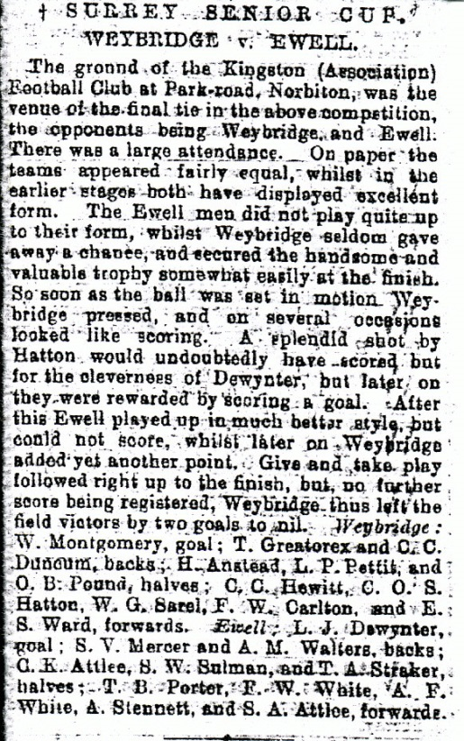
couple of seasons, by which time the players were getting older and more concerningly, very few were local to the town of Ewell. There was no issue with finance as many members of the club were extremely well off, but they just struggled for playing numbers.

They reached the Semi-Final of the Surrey Charity Shield once again in 1901 but were humbled 5-1 by Reigate Priory and did record a fine 5-2 win over an up and coming Woking side in the County Cup in November 1903, but it was the last cup tie they would win, losing to Croydon in the next round and then going out to Croydon Wanderers in October 1904.

By now they were no longer invited into the Charity Shield competition and despite attempts by Alex White, by now the Club Secretary and a member of the Surrey F.A. Council, only seven players made the journey to Croydon for an 11-0 defeat in a Mid Surrey League match that would ultimately prove to be their final contest.

In that line-up was Barry Porter, by now converted from a winger to a full back, and a youngster Alfred Revell who would go on to play for other Epsom sides before World War One, but for this team, it was all over.

The Sutton Advertiser scathingly wrote "I don't know what view the Surrey FA or whoever is responsible for the MSL will take of the action by Ewell in turning out four short at Brigstock Road". "Under the circumstances (Ewell had turned out three players short at Croydon a few weeks ago and the League ordered this match to be replayed) one naturally imagined that Ewell would have made special efforts to have been fully represented but they evidently have but small regard for the powers that be." "There was a time when Ewell were rightly regarded as a good sporting side, but repeated failures to keep their engagements in Croydon have gained for the club an unenviable reputation, and in the interests of other clubs they should be taught a pretty severe lesson." No blame was attached by the Advertiser to the Ewell players. "I felt sorry for Porter and the other plucky fellows who kept going to the end despite the rough and ready criticisms of the irate onlookers." Clearly the Advertiser had no idea of the mess the club was in by this time and somewhat harshly some of the criticism was aimed at

Alex White, who pointedly hadn’t travelled for that last fixture.

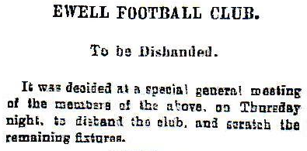
On the 16th February 1905 a meeting was held to decide whether the Ewell club should continue and the decision was made that it wouldn’t. Thus fifteen years of history were consigned to the memory banks and forgotten by almost everyone for a hundred years until brought back into the public eye when our history book was written in 2007.

Both Porter and Alex White were still under thirty and had more to give as players, but neither lived nearby anymore and White joined Wallington briefly, also guesting for Reigate Priory and Croydon before moving more permanently to play for top Amateur side Townley Park. Porter became a fixture in the Reigate Priory side and from 1905 became Captain of Surrey, a position he would hold until the famous “split” in 1907 which saw the formation of the Amateur F.A. and the Professional F.A. and lead to the creation of leagues like the Southern Amateur League in which Reigate Priory now became members. Porter then became Captain of the Surrey A.F.A. side and may well have been the only player to hold both positions.

Porter and White were also Surrey F.A. members until the split and after it White became a Vice-President. Indeed his wife presented the first ever Surrey A.F.A. Cup to Barry Porter as Reigate Priory became the first winners of the event in 1908.

Porter was no longer playing for Priory in late 1909 as they met Townley Park in a friendly, who contained Alex White, still participating at the age of 34, although as a defender by now, and there my playing records end of these two, although both survived the terrible 1914-18 World War that would follow.
Back at West Street, football continued and the ground was used by the Old Boys of the City of London, the “Old Citizens” from September 1905 until the outbreak of War. The ground then lay derelict until a junior Ewell F.C. formed in the 1919/20 season but they of course were turfed out when Epsom Town bought the ground in 1925 and retired to Ewell Recreation ground where they remained until folding in 1932.

Our original founders all lived long lives. John Henry Bridges died in Eastbourne on 12th February 1925 at the age of 72, survived by his wife Dorothy, while Percy Walters, the eldest of the two brothers, died on 6th October 1936 at the age of 73. Younger brother Arthur died in Coldharbour, where he is buried, on the 2nd of May 1941, aged 76.

So there we have it. The history of a club in a (fairly large) nutshell. Although the club rose like a firework and tailed off very badly in the 20th Century, without it and its founders, there would have been no West Street to move into and our own history would have taken either a completely different turn or hit a massive dead end almost before they had begun.

And it all started 125 years ago tomorrow. Happy anniversary to Ewell and West Street!

From behind the goal
Cove 0-7 Epsom & Ewell
Combined Counties League Premier Division - Saturday 3rd October 2015

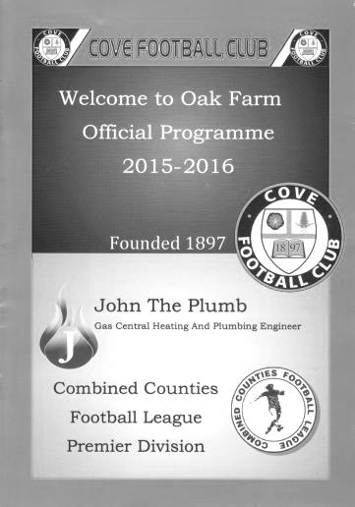
A magnificent seven for the Salts

Oak Farm is a venue where we have had a fair deal of success over the twenty five years that we have been making this journey, and another happy chapter was written today as we handed the hosts a football lesson to go top of the table.

Our record for this day in history is average but has improved recently and we haven't lost on 3rd October since 1978! It was clear very early on in this match that this particular record would be extended but what we didn't know at the time was that by the end of the game we would be celebrating our best away victory since 1975 with only four bigger away wins in history.

There were a few changes to our line-up. Michael Eacott returned in goal while at the back James Taylor came in for Craig Hastings and up front our leading scorer Kyle Hough returned for the injured Daryl Cooper-Smith. What is also heartening is that we appear to have a very strong bench too these days with plenty of options for Assistant Manager Matt Smith, taking charge in Glyn Mandeville's absence. Competition for places is very fierce right now.

We were off to a flying start, going two-nil up inside five minutes. Early pressure on the home defence told almost immediately as a ball in was only half cleared and Rob Hendry drilled a low shot past the unsighted Jamie Cunningham from the edge of the box in the third minute. Then on the left, a pass in to Hough saw him execute a dummy that left his defender for dead and he simply slotted the ball past the helpless keeper from six yards out.

Confidence was high and we continued to threaten with Hough in particular doing well to control a Hendry pass before drilling his shot inches over the bar after 25 minutes but six minutes later we had extended our lead as a deep right wing free kick was spilled by the keeper under pressure from Alex McKay and as it fell, our man knocked it forward with Matt Farrell then getting a toe to the ball ahead of a defender to knock it in from close range.

Eacott was tested with a decent effort from out on the right wing but got down well to keep the ball out, before we extended our lead in some style in first half

injury time. Matt Ferdinando robbed a defender on the touchline and he fed Hendry who then curled the ball from nearly twenty five yards right into the top corner for a four goal lead at half time; something we achieved last December at Frimley Green in the League Cup, but hadn't managed in the League since a 5-0 win at Dorking in 2010 when we scored all five in the first half.

However, on this occasion we were not happy with the four goals and kept pushing, being unfortunate not to score twice in a minute. Firstly Hough set up Farrell who lofted his shot above the advancing keeper, but he made a really good save for a corner and was then equal to an Alex McGregor volley from the edge of the box from the set piece.

We had a scare after 59 minutes when Taylor made a hash of a routine clearance, requiring Eacott to make a great one handed save, but we scored our fifth in the 66th minute. The ball came in from the left to McGregor and he flighted a pass on to Hough. The ball was diverted upwards by a defender's header but as it dropped it was met by a really special strike by Hough, turning in the same motion as he volleyed the ball low past the by now weary Cunningham.

The hosts thought they had scored a consolation but were ruled offside and we made it 6-0 in the 83rd minute. A dangerous diagonal ball was fed in from the right hand side and at the far post was substitute Dale Marvell who just had to slot it past the exposed keeper from eight yards. Five minutes later we had a magnificent seventh goal when the hosts switched off for a short corner, which Hough brought in and curled with his left foot right into the far top corner of the goal. This was Kyle's seventh hat trick for our club and he is now up to ten goals in ten games this season as he homes in on the ever nearer two hundred mark.

The carnage mercifully for Cove ended there, although in injury time Hendry missed two glorious opportunities to score his own hat trick; the second of which was a break through that left him one on one with the keeper but Cunningham guessed correctly and diverted the shot for a corner.

On another day we could have scored more goals but that is often the case when so many opportunities present themselves. The hosts are clearly in a rebuilding mode, but they were outclassed for large parts of the game and make no mistake, we will not face weaker opposition in the League this season. It is to our boys credit that they went out and controlled the game from the start, remaining clinical throughout the game in our search for goals that may come in useful come the season's end, as it is very possible right now that we might be at the business end come the end of the season. Well played lads!

Team: Michael Eacott, James Taylor, Matt Tanton, Dan Dean (c), James Taylor,
Alex McKay, Alex McGregor, Matt Farrell, Kyle Hough, Rob Hendry, Matt Ferdinando

Subs: Rhys North for Ferdinando (45), Dale Marvell for McGregor (67),
David Neill for Tanton (82)

U.S. Chantilly – Who are they?

Union Sportive de Chantilly play in the French footballing pyramid. Because there are fewer teams in this pyramid than in ours, it is hard to work out an exact comparison between us and them, although they are currently in the Championnat de France Amateurs 2 Section which is split into eight regions across the country, so I would hazard a guess at a similarity with our own Step Four.

“So what?” I hear you say. Well, many of you will not be aware that the town of Chantilly is actually twinned with Epsom. The connection is mainly through the fact that both teams are not far from their capital and both have famous horse racing venues. They host the Prix du Jockey Club, which is the third of the five Classic flat races in the French calendar. We also have five, two of which are of course at Epsom; the Oaks and the Derby.

Additionally, in case you hadn’t heard, England will be based there for the duration of the Euro 2016 football tournament. (about two weeks! – Ed)

So I thought we’d find out a bit about them. They were founded in 1902 and play at the Stade des Bourgognes which they appear to share with their town’s rugby club. Of course many grounds in Britain are wholly owned, while those on the continent tend to be multi-use council facilities and this site, nearby to the local college, seems to fit the traditional bill.

And here is a view of their ground. At least this is how it appears based on a fairly uncomplimentary report from the Daily Mirror so don’t believe everything you read! We’ll have another look in later in the season.

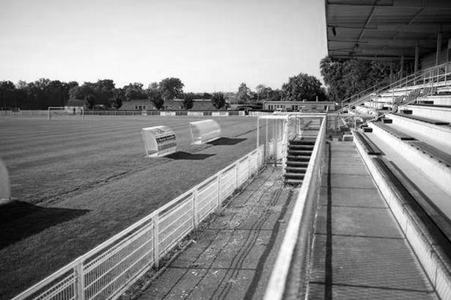

A magnificent Seven at Cove!
The 7-0 win at Cove was our biggest away League win since 1975. To commemorate this, I thought we’d have a colourful look at the goals, seeing as Gemma captured so many of them! 1) Matt Farrell scoring our third goal 2) Rob Hendry scoring our fourth.
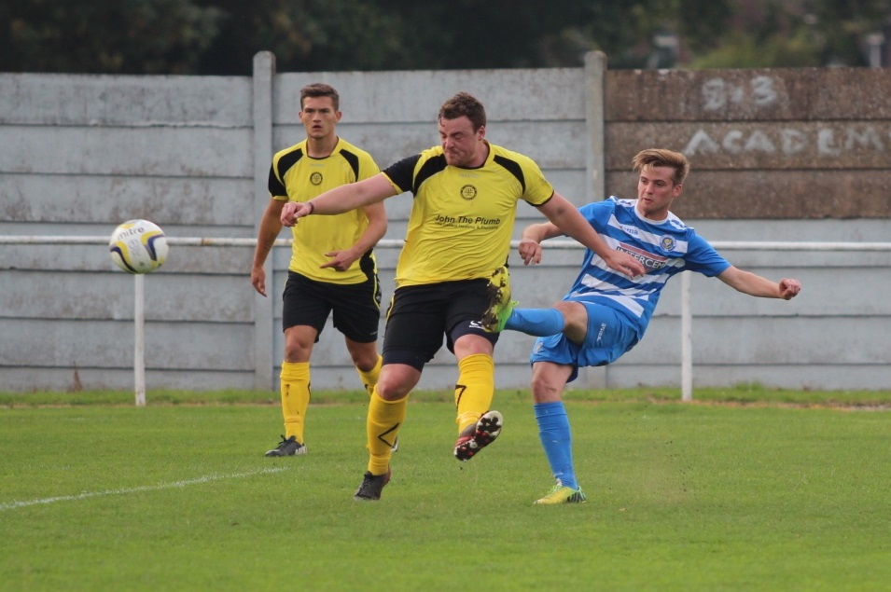
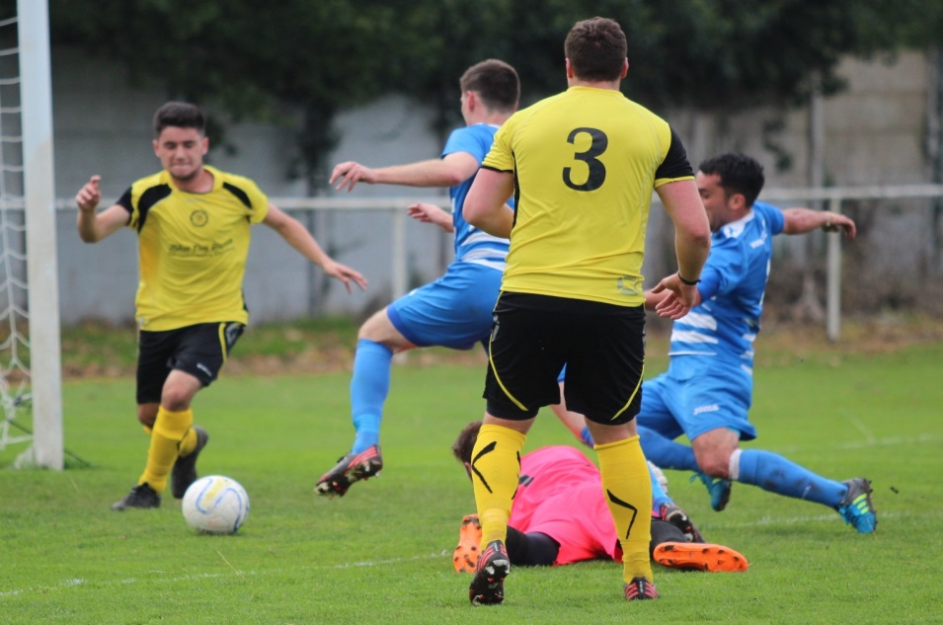

Centre page for results

Centre page for results

A magnificent Seven at Cove!
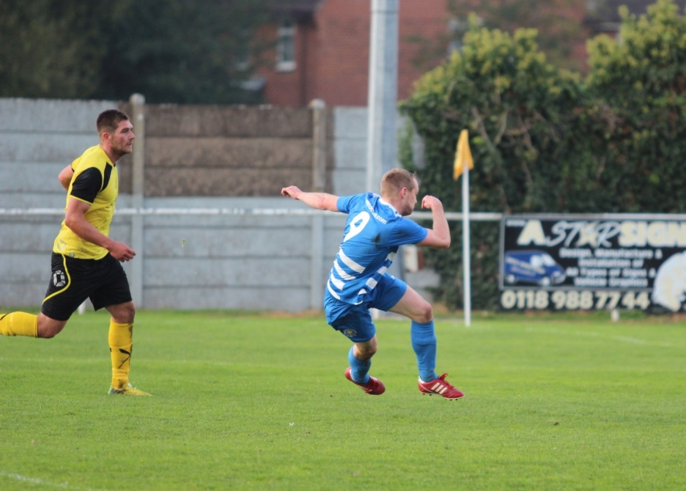
Above: Kyle Hough scores our fifth goal with a superb volley
Below: Kyle completes his hat trick with our seventh goal into the top corner.
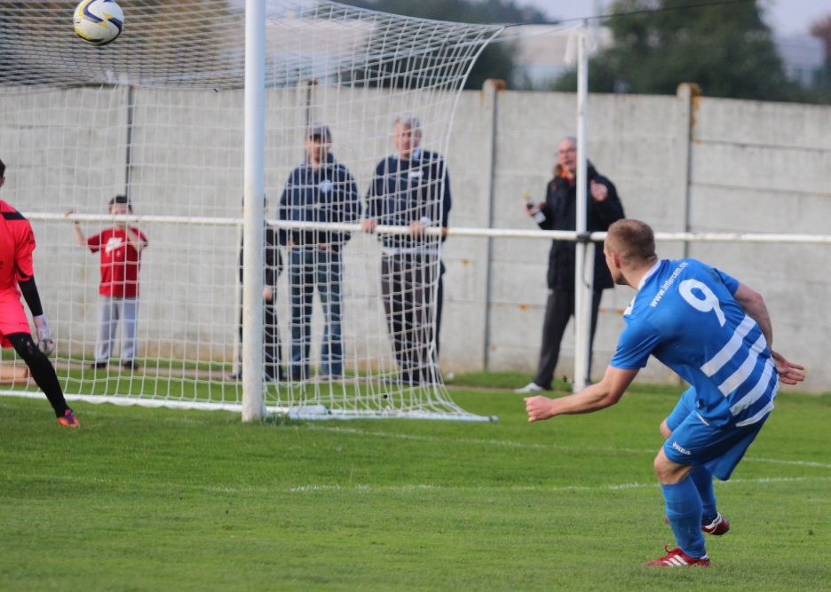

EL Records Premier Challenge Cup
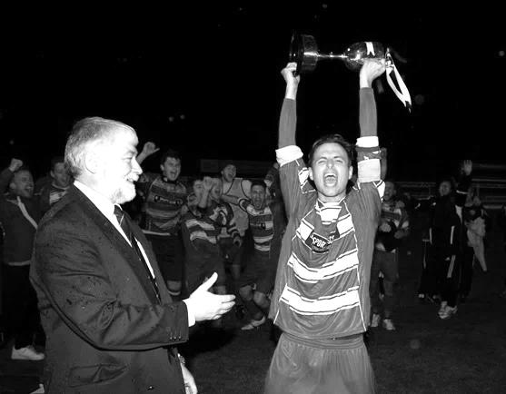
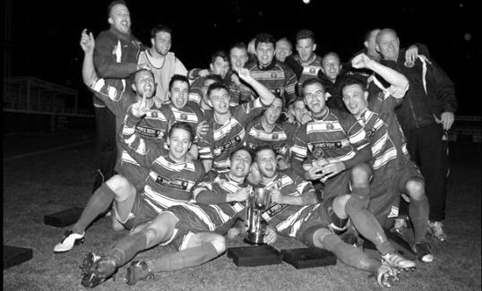
First Round
Farnham Town | 3-1 | Ash United
Horley Town | 4-1 | Staines Lammas
Windsor | 4-5 | Colliers Wood United
Redhill | 5-2 | Sandhurst Town
Sutton Common Rovers | 1-0 | Guildford City
Bedfont Sports | 1-3 | Abbey Rangers
Westfield | 3-1 | Farleigh Rovers
Second Round
Dorking Wanderers | 2-1 | South Park Reserves
Westfield | 1-0 | CB Hounslow United
Bedfont & Feltham | 1-5 | Colliers Wood United
Dorking | 0-3 | Knaphill
Badshot Lea | 2-4 | Spelthorne Sports
Hanworth Villa | 1-2+ | Chertsey Town
Ashford Town (Mx) | 2-1 | Epsom Athletic
Hartley Wintney | 4-2 | Horley Town
Banstead Athletic | 1-1+ | Epsom & Ewell
Epsom & Ewell won 7-6 on penalties
Sheerwater | 3-3+ | Frimley Green
Frimley Green won 8-7 on penalties
Farnham Town | 3-2 | Abbey Rangers
Camberley Town | 4-2 | Eversley & California
AFC Hayes | 0-1 | Banstead Athletic
Redhill | 3-0 | Sutton Common Rovers
Worcester Park | 1-5 | Chessington & Hook United
Cove | 1-6 | Cobham
Third Round
Camberley Town | V | Spelthorne Sports
Cobham | V | Frimley Green
Redhill | V | Farnham Town
Raynes Park Vale | V | Westfield
Epsom & Ewell | V | Ashford Town (Mx)
Colliers Wood United | V | Dorking Wanderers Reserves
Knaphill | V | Chertsey Town
Hartley Wintney | V | Chessington & Hook United



Surrey Senior Cup
Our successful Surrey Senior Cup winning team from 1981

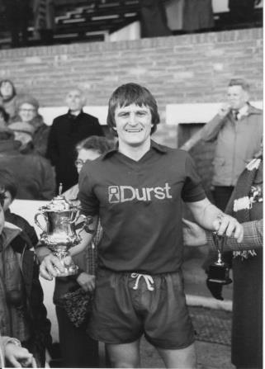
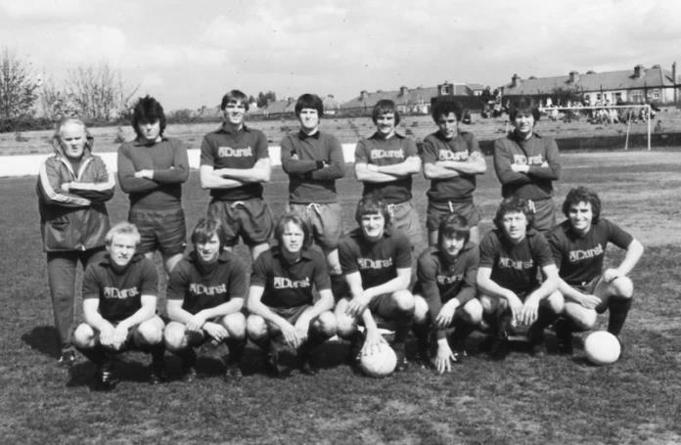
First Round
Ashford Town (Mx) | 27/10 | Beckenham Town
Camberley Town | 20/10 | Knaphill
Epsom & Ewell | 20/10 | Dorking Wanderers
Second Round
2 | V | 1
Chipstead | 3/11 | Chessington & Hook United
Colliers Wood United | V | Whyteleafe
Corinthian Casuals | V | Egham Town
Croydon | V | Farnham Town
Godalming Town | 10/11 | Guildford City
Horley Town | 1/12 | Badshot Lea
Leatherhead | V | Carshalton Athletic
Merstham | 1/12 | South Park
Met Police | 1/12 | 3
Molesey | 1/12 | Raynes Park Vale
Redhill | V | Tooting & Mitcham United
Sutton United | 30/11 | Walton & Hersham
Walton Casuals | V | Kingstonian
Westfield | 1/12 | Chertsey Town
Woking | V | Sutton Common Rovers

F.A. Vase
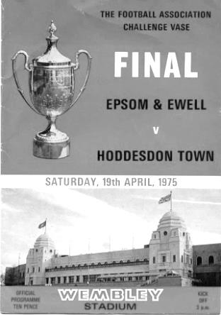
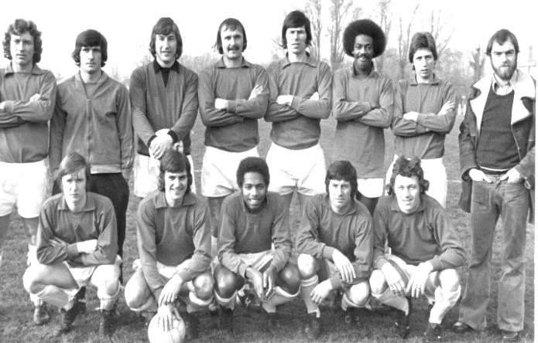
First Round – 31st October – South East Section
Stotfold | V | Newmarket Town
Cricklewood Wanderers | V | Welwyn Garden City
Diss Town | V | Basildon United
Barking | V | Tring Athletic
Bowers & Pitsea | V | Hanworth Villa
Hadley | V | FC Romania
Northampton Sileby Rangers | V | Wembley
Brantham Athletic | V | Kirkley & Pakefield
Gorleston | V | London Tigers
Ipswich Wanderers | V | Takeley / Hoddesdon
Berkhamsted | V | Northampton Spencer
London Colney | V | Great Yarmouth Town
AFC Dunstable | V | FC Clacton
Raunds Town | V | Sleaford Town
Hertford Town | V | Eynesbury Rovers
Godmanchester Rovers | V | Mildenhall Town
Ilford | V | AFC Kempston Rovers
Sporting Bengal United | V | Southall
Swaffham Town | V | FC Broxbourne Borough
Edgware Town | V | Whitton United
Cogenhoe United | V | Biggleswade United
Harefield United | V | Greenhouse Sports
Eastbourne Town | V | Farnham Town
Hartley Wintney | V | Wokingham & Emmbrook
Worthing United | V | Sutton Common Rovers
Knaphill | V | Cray Valley (PM)
Deal Town | V | Oxford City Nomads
Littlehampton Town | V | Tadley Calleva
Andover Town | V | Newhaven
Cove | V | Canterbury City
Corinthian | V | Pagham
AFC Croydon Athletic | V | Beckenham Town
Loxwood | V | Highmoor Ibis
Haywards Heath Town | V | Alton Town
Kidlington | V | Ashford Town (Middx)
Bedfont Sports | V | Carterton
Lancing | V | Camberley Town
Gravesham Borough | V | Hailsham Town
Windsor | V | Croydon
Steyning Town | V | Horsham
Thame United | V | Bridon Ropes
Meridian VP | V | Lordswood

My First Game
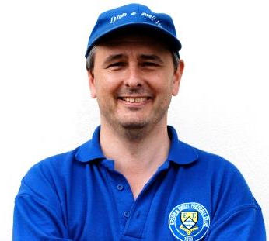
On this very day thirty-four years ago, I became an Epsom & Ewell F.C. supporter. To commemorate this sentence milestone I thought I’d have a quick look back.
---------------------------------------------------------------------------------------------------------------------------------------------------------------------------------------------------------------------------------------------------------------------------------------------------------
Epsom & Ewell 2-4 Hastings United
F.A. Cup Third Qualifying Round
Saturday 17th October 1981

I remember my first game very clearly. I was a 14-year-old schoolboy and was in my third year at Epsom High School. I used to travel to school by train from my home station of Stoneleigh to Ewell West, often cutting across the park and down West Street before crossing the railway bridge at the end and following the path into Longmead Road.

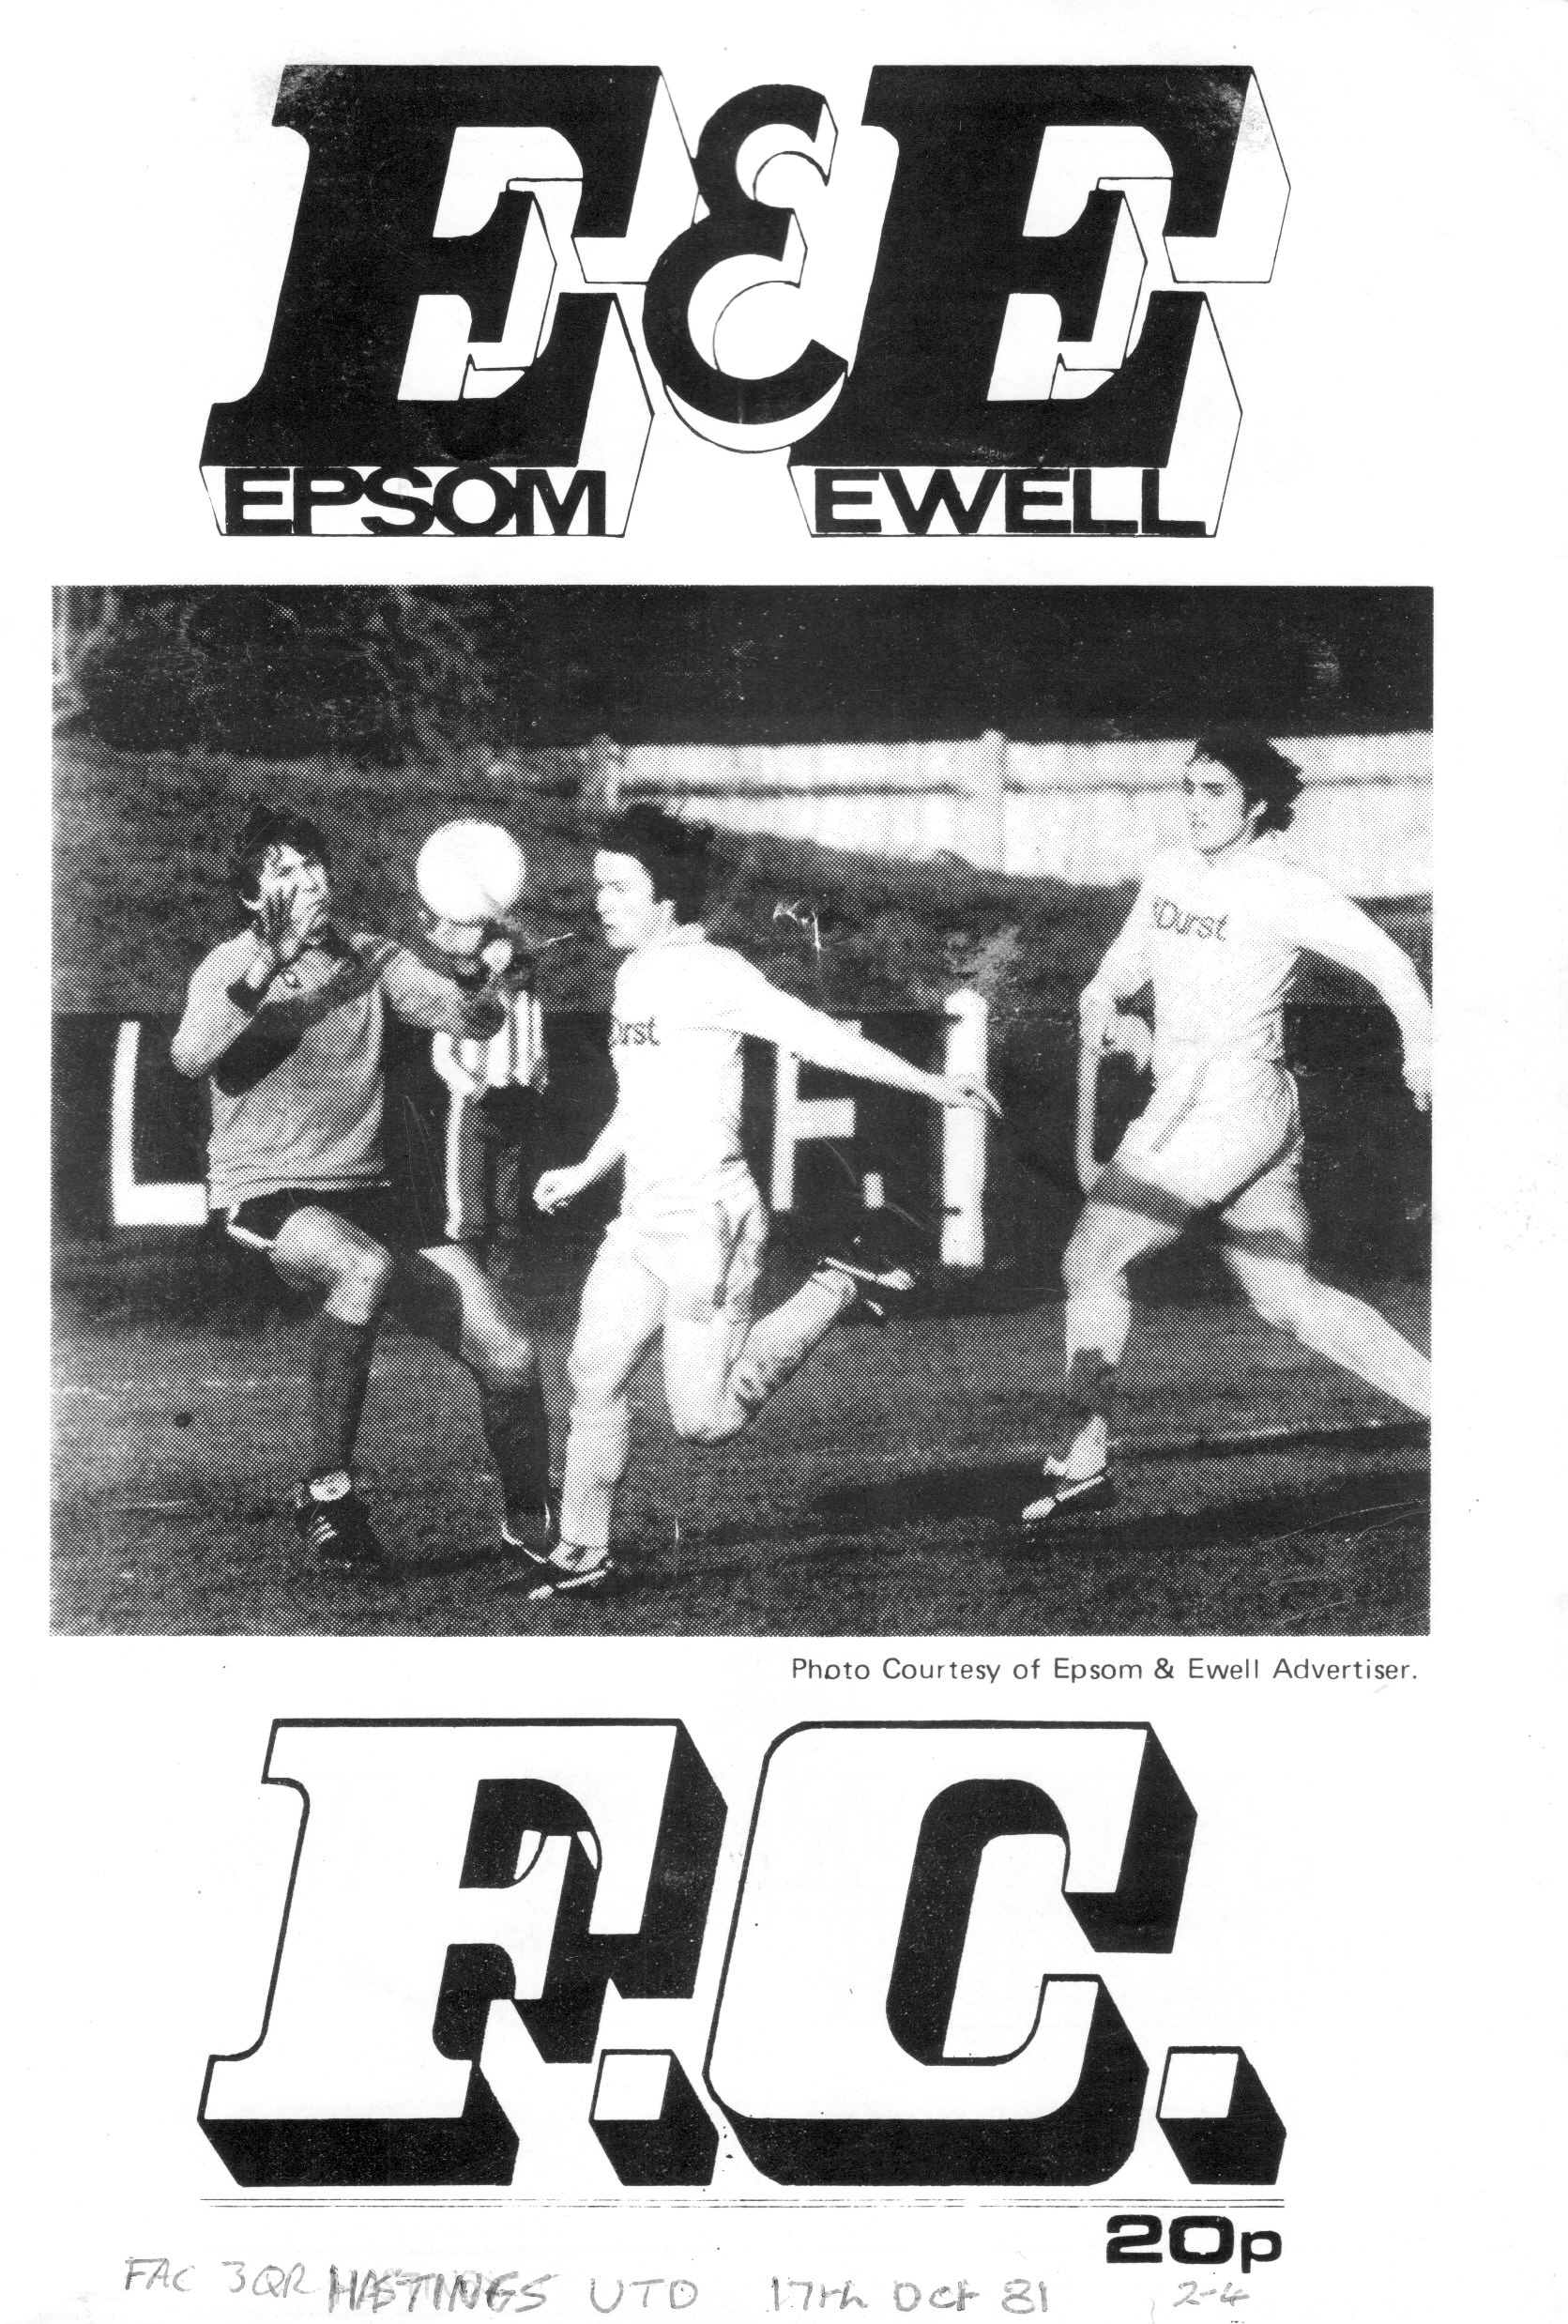
In the previous two years at Epsom High my P.E. teacher had been Steve Hill, and although he had departed for Therfield in 1981, he had changed football clubs too, moving from Hampton to join us in that summer. This made me even keener to finally go and watch.

By that time I had already been following the club’s reports for around a year by way of the excellent local papers, the Advertiser and the Herald. I particularly enjoyed the Advertiser’s reports with regular coverage by Fred Philpot, who had been watching the team for quite a while, and although he worked for the press and covered many different games, his main club appeared to be ours.

Through his writing, I was aware that we were playing at Enfield back in November 1980 and that we would be in the First Round of the F.A.Cup if we managed to win, (we lost 5-0!) yet it would be another eleven months before I finally managed to visit.

The occasion was another F.A.Cup match. I had read that we had drawn 1-1 at Premier Division Croydon and if we won the replay we would be at home again on the Saturday to Hastings United. I made a promise to myself that if we defeated Croydon I would go to the Hastings game. I waited until Thursday afternoon when the local paper arrived, as there was no other way I knew of to find out the score back then. Fortunately we won 4-0 so I was on my way to my first ever Epsom & Ewell match!

Many people that are long serving supporters first visited with dads or uncles, but whilst my dad enjoyed football, he wasn’t that bothered about going, So on the Saturday I dragged my somewhat reluctant younger brother Martin along to the game, although I think I offered to pay for his train fare (20p) and his entry (30p).

I entered through the turnstile and wandered in to the ground that I had only been able to see the outside of for what seemed ages. I declined the opportunity to purchase a programme at the blue caravan to the side of the turnstiles and wandered forward so that I could see the ground, and then paid for us both to enter the stand (30p) as I thought it would give us the best view of the game, and the ground too.

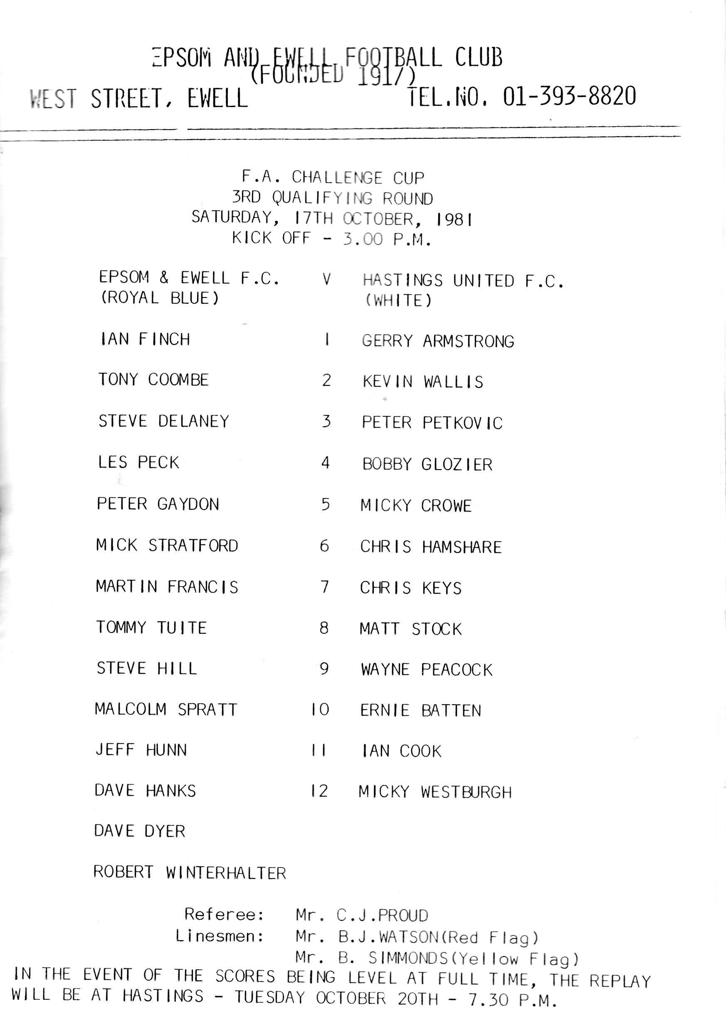
Now I should explain that this was my first ever senior football game of any description. The first team I ever watched was Epsom & Ewell, so I had nothing to compare our ground with. But it looked really good. It had a big clubhouse, a big stand and a surprisingly large looking slope. There was also a large grassy bank at the bottom end of the ground towards the station with a few steps of terracing on the far side, while facing us more or less straight across the ground was a large advertising hoarding that had clearly seen better days.

Just up the hill from there were the dressing rooms, and as the players came out, I looked for the one that I would definitely recognise. Alongside Hill was a smaller chap that I instantly knew from match report descriptions was Tommy Tuite, and it was he that put us 2-1 ahead at half time, following an earlier Jeff Hunn penalty.

At the break, I realised that I needed to know more about “my” new team, so ventured back to Sam Rugman the programme seller who was just closing up the caravan. Thus began my love affair with programmes that continues to this day.

Some other things haven’t changed either, and even with a great team thirty years ago we were also quite capable of losing a lead, eventually being defeated 4-2 by our Southern League opponents who had a man, Chris Hamshere, sent off towards the end I recall.

But despite the defeat I had enjoyed everything else about the experience and was determined to visit again. As I left the ground I asked my brother if he was interested in coming along for the F.A. Trophy game with Thanet United at West Street the following Saturday. “No thanks” he said, or words to that effect! As a result, he missed a 6-0 win and I was hooked!

What about you? Do you recall your first ever match for the club? Would you be prepared to write a few lines about it for the programme? This is not just an open invite for the columnists, this is for everyone including the players and Management, and I can add pictures where required to add memories for our readers. Go on, have a go!

From behind the goal
Banstead Athletic 1-1 Epsom & Ewell – after extra time
Epsom & Ewell win 7-6 on penalties
Combined Counties League Cup – Second Round - Tuesday 13th October 2015

Poetic justice as Salts survive shootout lottery at Merland Rise

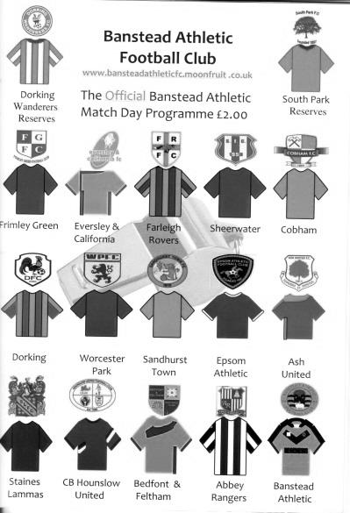
What started out as a routine assignment for our boys turned into a nerve-shredding battle in more ways than one as we somehow scraped past Banstead Athletic in the League Cup last night.

David Neill came into the starting line-up for Matt Tanton, but otherwise it was the same eleven that had played so well at Cove ten days ago and we started the fresher of the teams, pushing them backwards and forcing former Salt Colin Harris in the Banstead goal to be very busy.

Kyle Hough was prominent early on as was Matt Ferdinando on the right wing and both had chances blocked from close range before Alex McGregor saw his free kick from 25 yards well saved. However we broke through in the 13th minute when a good pass into the left hand channel put McGregor through and his low shot had the pace taken off it by Harris but the ball still had enough momentum to cross the line and we were ahead.

Further pressure ensued but the game turned on an incident in the 22nd minute when Sam Currie delivered a cross and then was clattered into by another former Epsom player Sean White. From his time at our club White appeared to be a fair player and a nice guy, but this challenge was a very poor and very late one and should have received a straight red card from the referee. Currie limped off and was replaced by Rhys North.

We should have extended our lead in the 30th minute when a superb cross from Ferdinando picked out Rob Hendry at the back post but his powerful header was directed wide of the goal from inside the six yard box. Then Colin Hartburn recklessly kicked out at Kyle Hough who was bearing down on goal and picked up another yellow card, which on another day could easily have also been deemed violent conduct. These challenges clearly threw us out of our stride although Dan

Dean, making his 50th appearance, had a header from a corner cleared off the line by a defender. The home side's first attempt on goal dribbled wide from 20 yards just before half time.

Early in the second half Alex McKay was unfortunate to see his well struck shot cannon off the base of Harris' right hand post but as the half continued the hosts and their fairly uncompromising tactics were getting back into the game. On the hour Dan Dean was replaced by Dale Marvell, but whether that was related or not we really went into our shell from that point. Michael Eacott was actually required to use his gloves on occasions, although he was then injured while tipping the ball over for a corner and required treatment on his back for a few minutes before being able to continue.

Our performance was falling apart at this point as Hough and Hendry were becoming isolated. We were struggling to exert any control whatsoever in midfield and considering that we had McKay and Matt Farrell in there this was a surprise. They weren't helped by an injury to Matt Ferdinando, just after we had made our third substitution in replacing Hendry with debut making Thomas Neale from Worcester Park.

Not that it was a concern as we only had to last a few more minutes, but in the 88th a deep right wing cross was met at the far post with a looping header and as it came back into play off the far post, no one reacted except their Captain Ashley Thompson who knocked the loose ball past the stranded Eacott from six yards.

The pace became even more frenetic as we entered our first extra time period since April 2014. In the opening moments they had a far post header while North had a try from 25 yards that forced Harris into a low save. Marvell conceded a free kick and yellow card moments later but Eacott tipped the ball over the bar from the set piece, and then made a great save as he spooned a downward header up and over the bar in the 12th minute of the extra period.

The second period was effectively played with ten men as Ferdinando was limping so badly by now that he played up front in the role of a passenger, in the way that used to happen in the old days when there were no subs available. McGregor moved to the right flank and Neale moved onto the left and it was from there that he beat his man, cut in and smashed a shot at goal from a narrow angle that flew away off the face of the crossbar.

The ball came back in and as it did, it was sliced over the bar by a defender, but this was a close one as the ball negotiated the crossbar in the same way a high jumper just clears his own barrier! From that corner McKay then had a header blocked by Harris with the loose ball being hacked clear just in front of the advancing Hough. Maybe it wasn't going to be our night.

With nine minutes remaining a high challenge on James Taylor from Sean Bradley warranted a straight red card in the referee's opinion but even then, the home side came closest to pinching the match with a good low save by Eacott, and then again with just five minutes remaining when we were all grateful that a header was directed straight at him from six yards out at the far post with the goal at the striker’s mercy.

So penalties it was, and we had the ideal start when Eacott threw himself down to his left to save Hartburn's penalty with Kyle putting us ahead with his usual clinical finish. Jake Wilgoss opened the Banstead account with a calm penalty to Eacott's right but McKay kept us ahead with a good finish. Thompson made it 2-2 with a penalty similar to Hartburn's but this time Eacott had gone the wrong way and this became more of a concern when Neale stepped up, went for power and sent the ball into a new orbit.

Level at 2-2 now the home side had the advantage of going first and former Epsom Reserves player Zak Nightingale scored as did Marvell. Robert Hill and Farrell were both successful to make it 4-4 and with five penalties taken each, we were into sudden death. Another former player Julian van Gelder scored his penalty while North casually knocked in his. The entertainment / torture continued as Billy Targett scored for them and McGregor netted the best penalty of the night to make it 6-6.

Then White stepped up but his penalty was a weak one and was easily blocked by Eacott, leaving Taylor to step forward and finish easily to put us through. It was interesting to note the lack of a real celebration from our players as the emotion was probably just one of relief, but it was ironic that White whose foul started the trouble off was the one to miss, while Taylor, who received the kick to the head from Bradley was the one to knock in the winning penalty.

In summary, we should have been well clear by the time Banstead got back into it, but unless you finish sides off when you have the chance, they will come back and bite you. This was ever so close to happening last night and it is largely to Eacott's credit that we are still in the competition today and looking forward to a home match against Ashford Town (Mx) in the last 16.

Team: Michael Eacott, Sam Currie (c), David Neill, Dan Dean, James Taylor, Alex McKay, Alex McGregor, Matt Farrell, Kyle Hough, Rob Hendry, Matt Ferdinando

Subs: Rhys North for Currie (28), Dale Marvell for Dean (60), Thomas Neale for Hendry (85)

Club Statistical History - (including Banstead Athletic match on 13/10/15):
League: Played: 2,805, Won: 1,147, Drawn: 532, Lost: 1,126
For: 5,150, Against: 4,993, GD: plus 157 - Win Ratio 40.89%

CCL only: Played: 384, Won: 173, Drawn: 74, Lost: 137
For: 684, Against: 607, GD: plus 77 - Win Ratio 45.05%

Cup and Other (inc Abandoned Matches):
Played: 1,095, Won: 518, Drawn: 128, Lost: 441 Abandoned: 8
For: 2,375, Against: 2,046, GD: plus 329 - Win Ratio 47.31%

Under Glyn Mandeville: Played 52, Won: 27, Drawn: 6, Lost: 19
For: 104, Against: 87, GD: plus 17 - Win Ratio 51.92%

Total: Played 3,900, Won: 1,665, Drawn: 660, Lost: 1,567, Aban: 8
For: 7,525, Against: 7,039, GD: plus 486 - Win Ratio 42.69%

First Senior Match: 30th August 1924.
Lost 1-3 vs Dorking at our home ground at the time of Horton Hospital Grounds.

First Match Programme Issued: 15th September 1923.
Won 4-0 vs West Norwood Reserves - Friendly match at Horton Hospital Grounds.

Number of Official Home Grounds: Six.

Alexandra Recreation Ground 1918-1922,
Horton Hospital Grounds 1922-1925,
West Street 1925-1993,
Merland Rise 1993-2010,
Moatside 2010-2012,
High Road 2012- present.

Record Win: 12/10/1935 - 13-1 v Reigate Priory (H) - Amateur Cup.

Record Defeat: 14/02/1948 - 0-14 v Chelmsford City Reserves (A) - London League.

Longest Serving Manager: 1) Adrian Hill 853 1982-1985 & 1990-2003
2) Pat O’Connell 466 1973-1982
3) Lyndon Buckwell 407 2006-2014
4) Ricky Kidd 190 1986-1990

Record Appearances: 1) Graham Morris 658 1990-2004
2) Nigel Bennett 630 1989-2005
3) Tommy Tuite 582 1973-1987
4) Ernie Watkins 419 1945-1960

Record Goal Scorers: 1) Tommy Tuite 391 1973-1987
2) Reg Marlow 254 1924-1936
3) Jimmy Jones 148 1933-1945
4) Kyle Hough 137 2007-present

Most Appearances in a season: Tony Coombe and Tommy Tuite - 59 in 1980/81.

Most goals in a season: Reg Marlow - 65 (at least) in 39 appearances in 1926/27.

Senior League Titles: 5 - 1925/26 Surrey Senior League - 1926/27 Surrey Senior League - 1927/28 London League - 1974/75 Surrey Senior League - 1977/78 Isthmian League Division Two

Every Opponent A-Z
Over the years we have played many, many different opponents. Exactly how many is a difficult question, as it all depends on your definition. Are Camberley & Yorktown different to Camberley Town, or are Epsom Town different to Epsom F.C. or Epsom & Ewell F.C.?

In my analysis I have classed them as the same team, and will work through them all from A to Z. Some we have played many times, whilst others we have met just once or twice. Enjoy!


Petersfield United / Petersfield Town: Played 13 - W9 D2 L2 - F30 A17 - PPG - 2.23 - Fantastic

A quick trip down the A3 takes you to the Hampshire village of Petersfield where the ground at Love Lane is on the one way system, so don’t miss it!

We first played Petersfield United, as they were then known, following our relegation to the Isthmian League Second Division South for 1987/88 and won our first two meetings comfortably; 5-1 at home on Saturday 21st November with two goals for debutant Alan Flaherty, and 3-2 in the return after leading 3-0 at half time, with Player / Manager Ricky Kidd scoring one of the goals.

A hat trick from Carlton Walcott was only enough to secure us a point from a 3-3 draw in our opening home game of 1988/89, which was played at Molesey’s Walton Road while we had new floodlights installed, although we again won at Love Lane in April thanks to a goal from youngster James Dack, who would go on to have a successful playing career that has recently involved a spell as Manager of Newport County!

In 1989/90 goals from Paul Andrews and George Smith gave us a 2-0 half time lead at Love Lane but we fell to our first defeat that day, conceding three times in the second half and providing an early indication of the weakness of the squad this season. By the time of our return win, 2-1 at West Street in January 1990 it was likely that plans were already afoot to replace Kidd as in March Adrian Hill returned to the club as Manager.

Which brings us on to the opening day of the following season on the 18th August. We won 1-0 in Hampshire but the game was more notable for the debuts of Graham Morris and Dave Hyatt, who would both provide sterling service for the club. Dave had a small spell away after that but still made 409 appearances, enough to place him in fifth on our all-time appearance list. Graham stayed with us for the next 14 seasons and remains our leading appearance maker with 658.

We won the return match 3-0 at West Street in January 1991 but both clubs failed to finish in the top half of the League that year and found themselves placed in the newly formed Division Three, although results remained in our favour as we completed a league double over them by 3-1 at home and yet again 1-0 at Love Lane with Morris scoring the winner.

The 1992/93 season would be the last time that we would visit their pleasant enclosure, securing a 1-1 draw, after having lost 2-4 at West Street in the August of 1992, which was also their last visit to our much-missed ground.

They resigned from the Isthmian League that season in an attempt to cut their debt but were denied permission to switch from the Isthmian League to the Wessex League as it was in the “other” half of the pyramid back then. Faced with this bizarre and blinkered F.A. stance they chose an unlikely course of action themselves by folding and reforming as Petersfield Town back in the Wessex League and had been there ever since.

Until this year, that is, as last season they won the Wessex League and are now finding

their feet in the Southern League Central Division, although they already have two notable F.A. Cup wins this season against Weymouth and Cirencester Town, both members of the Premier Division.

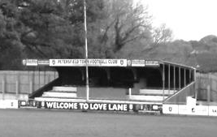
The main stand at Petersfield Town, slightly changed from the days when we used to visit

McLaren Sports / Petter Sports: Played 6 - W4 D0 L2 - F15 A14 - PPG - 2.00 - Very Good

Firstly I must confirm that contrary to current opinion, the club name is not and never was Petters Sports. Originally known as Lagonda Sports (although no connection to Staines Lagonda, an earlier incarnation of Staines Town) they joined the Surrey Senior League in 1946 and became McLaren Sports in 1948 before changing again to Petter and Bryce in 1956 and then adopting the shorter name in 1959. As you might expect, they were a company that specialised in the motor industry, although restricted themselves to accessories in later days. Our first two meetings were against McLaren Sports and the remainder were against Petter Sports.

We first met them on 14th October 1950 at West Street in a Surrey Senior Cup tie while they were members of the Surrey Senior League, winning 3-1 with two goals from Player / Coach Sid Faggetter and one from Tommy Wright and in February 1955 we defeated them 3-0 on the way to winning the Surrey Senior Shield with goals from Dick Muirhead, Les Peake and Gordon Hurst.

We first visited their old ground, a stone’s throw away from the current Egham Town ground, in Green Lane on 22nd October 1960 but lost the Surrey Senior Cup tie 3-0 and our only other visit there came in the Surrey Senior Shield on Wednesday 29th April 1963 when a weakened team travelled there and lost 6-0.

In between those matches we met at West Street on 30th September 1961, winning an Amateur Cup tie 5-3 but only after trailing 2-1 at half time, and our final meeting came in the same competition when we won 4-1, again at West Street with a hat trick from Peter Deadman who would go on to have a massive career as an England Amateur International with Hendon.

The club didn’t last much longer even though the company name remains, and the sports ground is now covered by housing.

Our friends Hoddesdon Town
Spartan South Midlands League - Current Table 2015/16
incl Wednesday 14th October | P | W | D | L | F | A | Pts | GD
AFC Dunstable | 10 | 8 | 2 | 0 | 30 | 8 | 26 | +22
Hertford Town | 10 | 6 | 4 | 0 | 30 | 15 | 22 | +15
Welwyn Garden City | 9 | 7 | 0 | 2 | 32 | 10 | 21 | +22
Hadley | 10 | 7 | 0 | 3 | 28 | 11 | 21 | +17
London Colney | 10 | 6 | 3 | 1 | 21 | 9 | 21 | +12
Berkhamsted | 9 | 6 | 2 | 1 | 26 | 10 | 20 | +16
Hoddesdon Town | 9 | 5 | 2 | 2 | 18 | 8 | 17 | +10
FC Broxbourne Borough | 11 | 5 | 2 | 4 | 22 | 22 | 17 | 0
Tring Athletic | 8 | 5 | 1 | 2 | 14 | 8 | 16 | +6
Sun Sports | 11 | 5 | 1 | 5 | 28 | 24 | 16 | +4
Holmer Green | 9 | 5 | 1 | 3 | 18 | 19 | 16 | -1
Cockfosters | 10 | 4 | 3 | 3 | 19 | 17 | 15 | +2
London Tigers | 9 | 3 | 2 | 4 | 12 | 19 | 11 | -7
Wembley | 11 | 3 | 1 | 7 | 10 | 17 | 10 | -7
Colney Heath | 12 | 3 | 1 | 8 | 12 | 38 | 10 | -26
Harefield United | 11 | 2 | 3 | 6 | 10 | 22 | 9 | -12
Oxhey Jets | 10 | 3 | 0 | 7 | 14 | 34 | 9 | -20
Leverstock Green | 8 | 2 | 2 | 4 | 18 | 20 | 8 | -2
Stotfold | 10 | 2 | 2 | 6 | 14 | 21 | 8 | -7
St Margaretsbury | 10 | 2 | 1 | 7 | 13 | 27 | 7 | -14
Biggleswade United | 9 | 1 | 1 | 7 | 5 | 18 | 4 | -13
Bedford | 10 | 0 | 2 | 8 | 11 | 28 | 2 | -17
I referred a few weeks back to Hoddesdon Town, hoping they wouldn’t be the first team out of the F.A. Cup with their Friday night match but I couldn’t have been more wrong! After defeating Sawbridgeworth Town, they knocked Step Four Romford out after a replay before winning at Ashford Town (Mx) and then won at 2-1 at another Step Four team Sittingbourne, before bowing out to Ryman Premier League Brentwood Town in a replay on Tuesday night, by which time well over two thirds of the entire number of eligible clubs for the competition, including us of course, had already been dispatched.

This confidence has spread to the League, where they lost their first two matches but have been unbeaten in their last six and are nicely positioned, with of course, games in hand as I write this.

It is interesting also to see our old friends from Hertford Town remaining unbeaten at this stage of the season but it is quite surprising how few of these teams we have actually met, when compared to the Southern League table we saw earlier in the issue. Both Berkhamsted and Tring Athletic are new clubs at venues we’ve visited, but it is only Hertford, Harefield United and more recently, Wembley that we have actually crossed swords with.

Scouting the Opponent – Dorking Wanderers
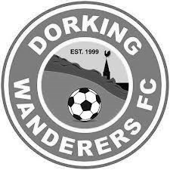
The draw gods have not been particularly kind to us this season, giving us arguably the best side in Kent and the best in Sussex in Erith & Belvedere in the F.A. Cup and Horsham in the F.A. Vase respectively.

Only six clubs out of 38 avoided a bye in the Surrey Senior Cup, so guess what? We now find ourselves drawn at home without a bye, against the new Ryman League hotshots, Dorking Wanderers!

New to the League they may be, but many of their players aren’t as they have spent a fair bit of money on some well-known local players like Tom Tolfrey, Kev Terry and Phil Page and that’s just the front line!

They clearly have their sights set on further progress up the pyramid and their prospective move to a refurbished Meadowbank for 2016/17 is going to give them the springboard to aim further than they could at their current pretty but modest Westhumble ground.

They remain in contention for the League and the Trophy too, so there is a possibility that they may not be too bothered about the County Cup, but I could be wrong, and we must expect a full strength side when they visit us in three days.

With the winners travelling to Imber Court to face the current holders Met Police on 1ste December, this draw gets no easier, but rest assured we will have a good go at them, cast as we are in the role of plucky underdogs with nothing to lose. You never know!

Below: Dorking Wanderers pleasant and picturesque ground.
Putting the humble in Westhumble!

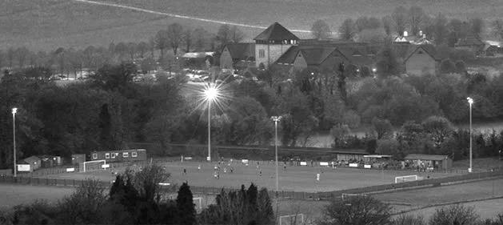

Chertsey Town – History
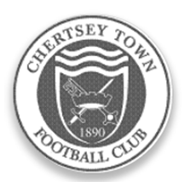
Organised football was evident in Chertsey well over a century ago but county affiliation did not take place immediately. The official founding of the club took place in 1890 when matches were played in the West Surrey League. The first success came in 1897 when the Surrey Junior Cup was secured. A one year gap took place before football resumed in the same competition which eventually became the East and West Surrey League.

A further halt in football took place during the Great War but soon after, in 1919, the club joined the Surrey Intermediate League where it stayed uneventfully, until 1939 and a further break. An invitation to become founder members of the Surrey Senior League was not taken up in 1923 but membership was later assumed, on attaining senior status in 1946.

The club has played at various locations within the parish (Willow Walk, Free Prae Road, Stained Lane and Chilsey Green Road) before settling down at the present home in 1929. The suffix ‘Town’ was added to its title some 21 years later. The ground was donated by Sir Edward Stern as a football ground to the ‘premiere club in the parish’. Next door, a similar trust provides facilities for Chertsey Cricket Club. The main stand was constructed in the mid-fifties; the original clubhouse added in 1960 and the first covered enclosure was built some three years later. Cover behind one goal was added in 1994.

Although Chertsey gained membership of the Surrey Senior League immediately after the Second World War, it was not until the 1959/60 season that success came with the League Championship. This was repeated twice in the next three years, a halcyon period when the League Cup was also won on three occasions. Due to the static nature of Amateur football in those days, the club could not progress to the preferred Corinthian League so, in 1963, it was controversially decided to turn professional and enter the Metropolitan League. Although an entertaining three years were then enjoyed, the cost was too much to bear and a return to lower levels of the Greater London League for one season occurred before a further shift to the Spartan League was made in 1967.

Indifferent results then dogged the club for almost two decades. This situation was briefly relieved in 1974/75 when the club were League and League Cup runners up to an up and coming Farnborough Town. Meanwhile, the fabric of the club was being built up behind the scenes and despite the lack of

prominence on the park, movement was made via the London Spartan (1975/76) and Athenian leagues through to the Isthmian family with a place in Division Two South in 1984. Instant relegation to the Combined Counties League was suffered but, a rejuvenated side won promotion back to the Isthmian ranks within the year winning the League Cup on the way.

The club was rewarded with good league positions but with further promotion denied at first. The worst season after returning to the Isthmians came when the two Division Twos were split in 1991 and a place in the new Division Three had to suffice. The position was quickly rectified with a runners up slot in 1992.

The club also reached the quarter finals of the F.A. Vase, emulating a similar performance in 1987/88. One year later 102 points and a runners up promotion place to Division One was nailed. The League Cup was also secured together with the Carlsberg Trophy in the same campaign along with the League Charity Shield.

Only one campaign was required in Division One before further promotion to the Premier Division. The first season at that level was one of consolidation but the second was more difficult. A late rally was experienced, but was insufficient to avoid the drop to Division One. Two subsequent Division One campaigns were comfortable but the third proved too difficult after a very poor first half of the season.

Relatively respectable positions were attained for the next two seasons and then a return to Division One, taking a place in the revised south section in the Isthmian re-organisation. The side was not able to compete at this level and relegation to Division Two was suffered in 2003. With the dissolution of the division, the club was allocated to Combined Counties in 2006. Promotionally hopeful situations were created regularly over the five terms in that competition. Finishing as runners up in 2011 was good enough on that occasion to secure promotion to Division One Central of the Southern League. Unspectacular, but safe, performances were achieved for two seasons but the relegation was suffered at the end of last season, and with it a return to the Combined Counties League.

The club which also has a comprehensive and integrated junior section of boys from all ages is sponsored by Traylen Enterprises; a nearby company that takes a great deal of interest in local community projects. The club now also supports a ladies team who play in the Greater London League.

Chertsey Town’s nickname, the ‘Curfews’ is derived from a locally famous bell that hangs in the nearby St. Peters Church. The bell has rung out the evening curfew, now ceremoniously of course, for over five hundred years.

Chertsey Town – Player Profiles
Daniel Alderton (24) A central defender who is in his third season with the club. Was previously with Raynes Park Vale.

George Armstrong (20) First featured for Chertsey Town in the Under 18 side then had a time at Spelthorne Sports.
Returned in early September. A goalkeeper.

Bobby Aspinall (20) Joined at the start of the season. A goalkeeper who played at Tooting & Mitcham United last season.

Tommy Batten (26) A midfield player who was previously with Corinthian Casuals but signed for the Curfews in the 2014 close season.

Joe Blendell (22) Midfield signing in August. Is also signed with Walton Casuals where he played last term.

Andy Crossley (22) An attacking midfield player in his second spell at Chertsey Town. Made his debut in August 2010 as a 17 year old. Re-signed in November 2014 after playing at Farnborough, Egham Town and Godalming Town.

Ross Cull (21) Signed in the close season. Previously with Cobham.

Ben Geraghty (21) Joined Chertsey Town’s front line in November 2014 but is more comfortable in defence.

Ben Heaton (27) Signed in mid-September, is a defender with wide non-league experience, but has recently re-emerged from local football.

Anthony Glover (24) Midfield engine with an eye on scoring spectacular goals. Signed in the 2014 close season. Previously played Step 4 football with Northern Premier League side Burscough.

Joe Jones (20) Midfield player who joined in the summer of 2014 from Harefield United.

Callum Lee (19) Joined in the close season. Was previously with Wessex League side Christchurch.

Abid Merali (23) Signed in the 2015 close season. Was a junior at Aldershot Town.

Steve Newman (23) Defender and captain who joined in the 2014 close season. Was with Erith Town and Epsom & Ewell prior to joining the Curfews.

Jack Ogle (23) Goalkeeper signed in the close season. Was with Lyne last season. A local lad.

John Pomroy (34) A striker in his third spell at Chertsey Town, having returned in December 2011. Came originally as a teenager from Fulham, then Aldershot. Has also played for Walton & Hersham, Lewes, Bognor Regis Town and Egham Town. Has made over 350 appearances for the Curfew and scored over 300 goals.

Meddie Nsubuga (31) A central defender signed in September. Is a former Ugandan international. Previously played for Slough Town Staines Town, Hampton & Richmond and Corinthian Casuals; also Ferros Corril of Argentina.

Jamie Ross (20) Wide attacking midfield player signed from local football at the start of the 2015/16 season.

Max Springall (20) Former Chertsey Town youth player who returned to the club in the summer. Plays an attacking role.

Joel Thompson (26) A striker signed in the 2015 close season. Was previously with Corinthian Casuals and was part of the squad that travelled out to Brazil on the club’s regular ‘pilgrimage.’

Lewis Wade (18) Just out of Chertsey Town’s Under 18 side in the summer and has already made an impact at full back.

Jack Wadmore (20) An attacking midfield player who signed in the 2014 close season. Was previously with Corinthian Casuals.

Kieran Woodley (20) An attacking An attacking wide player who first signed in August 2014 Moved to Redhill for the start of this season but re-joined the Curfews in October 2015.

Matches against Chertsey Town
We have met Chertsey on 45 previous occasions, and results haven’t gone well, over that time, with many defeats on our record. However, in recent seasons there has been an improvement with five wins in our last eight meetings and two wins in a row at Alwyns Lane, something we had not achieved at any time previously.

As you might expect though, I’m going to start with the earlier matches. Our first ever match technically between an Epsom team and a Chertsey team were when Epsom met Chertsey Reserves in the Final of the Surrey Junior Charity Cup on 6th April 1907, when an earlier incarnation of our Epsom side won the cup 5-0 at Alexandra Recreation Ground in front of a crowd of around 400.

However, in terms of the two current teams, our first meeting was an Amateur Cup tie at Alwyns Lane on 2nd October 1948, which was drawn 2-2 after 90 minutes, with extra time failing to produce another goal. Kenny Minter and Jimmy Emblem scored Epsom’s goals. Unfortunately Emblem was injured after three minutes of the replay the following Saturday, leaving our boys with ten men, but we still managed to win the replay 2-1 with goals from future Manager Fred Chitty and Jackie Collins.

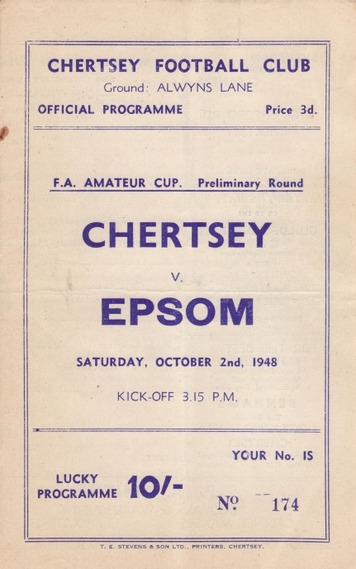
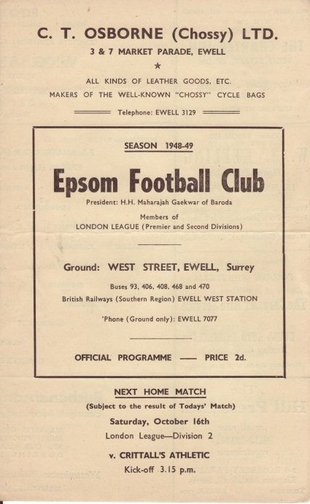
Our next meeting was another Amateur Cup tie two years later on 21st October 1950, when Epsom trailed 4-1 at half-time, but recovered to win the tie 5-4, thanks to two goals from Sid Faggetter, and others from Mick Colwell and Pat Jordan. Tommy Wright

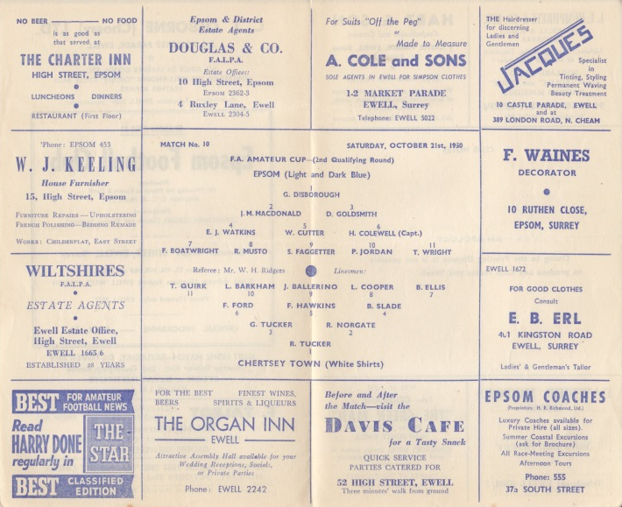
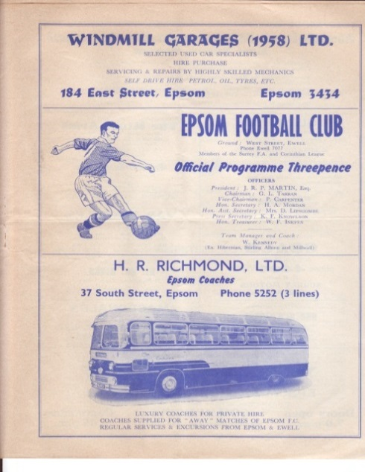
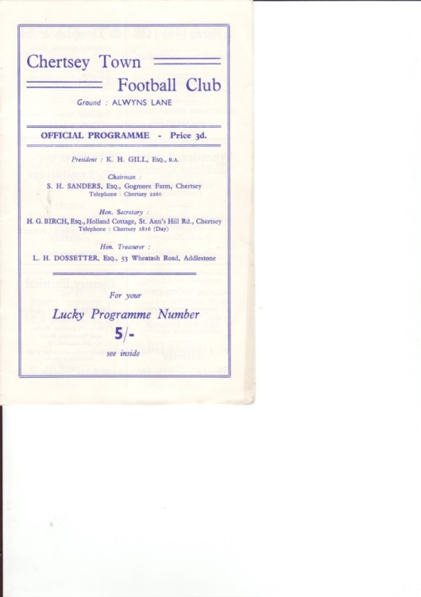
scored the winner that day. In 1959 Chertsey beat us in two competitions, winning 3-2 at West Street in the Amateur Cup, and 4-3 in the Surrey Senior Cup at Alwyns Lane, even though we had led 2-1 at half time.

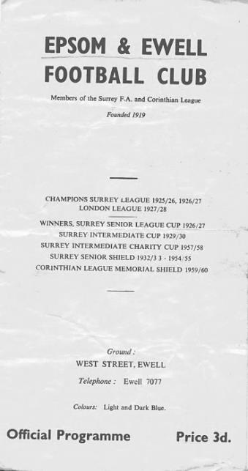
We next met in 1962, and again it was a Surrey Senior Cup tie which was lost by the same 4-3 scoreline, although this contest was at West Street and required extra time at 3-3. We had led 3-2 at the half, through goals by Taz Arnall, Gerry Jenkins and Sid Dobson.

Maybe fortunately, it wasn’t for another 25 years before we met again, once the Blues had been relegated to the Isthmian League Division Two South, when a Luke Harding winner seven minutes from time gave Epsom a 2-1 win.

However, wins were very rare and we would only record four more wins from our next 14 meetings, by which time Chertsey had moved up to compete with the top clubs in the Isthmian League.

By the time of our next meeting it was 2002 and we had just been promoted into the Isthmian League Division One South. This season was not a good one for the Curfews and we won both matches 3-0 as they finished bottom and went down.

We weren’t up there for long though and in 2004/05, by now back in the Ryman League Division Two together, we met four times, failing to win any of them, including an Associate Members Trophy Group game that many supporters completed a sponsored walk to in September 2004!

2005/06 contained an improvement as we beat them 4-2 at Merland Rise with three long range strikes marking the win although by the time of our return fixture eleven days later we had dispensed with the Manager Ray Purvis. This game was best remembered for the award of three penalties to the home side, fortunately they only scored two of them and we escaped with a draw.

We both transferred across to the Combined Counties League in 2006 and we won just one of our next seven matches against them before trailing 2-0 at home on 19th September 2009, but two goals from Ben Hayward followed by a last minute winner from Robbie Burns made for a special and well-remembered celebration! (see picture)

Since then results have been more even and we had the luxury of a Kyle Hough missed penalty, his first in 28 attempts as we defeated them 2-1 at Alwyns Lane in January 2011. However, they had the last laugh, winning the return match 4-1 at our temporary home at Moatside and being promoted to the Southern League at the end of the season.

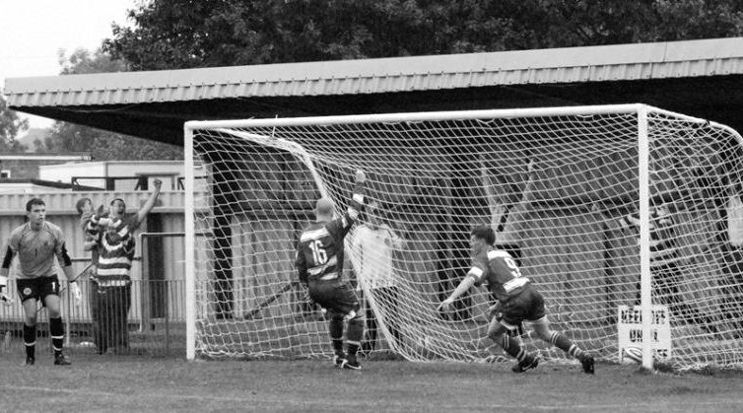
Last season they returned to our League and both clubs won their away fixture in unusual circumstances. We lost 2-1 here to a nine man Chertsey side on 28th October 2014 but won the return fixture on 14th March 2015 by the same score, despite finishing with ten men ourselves.

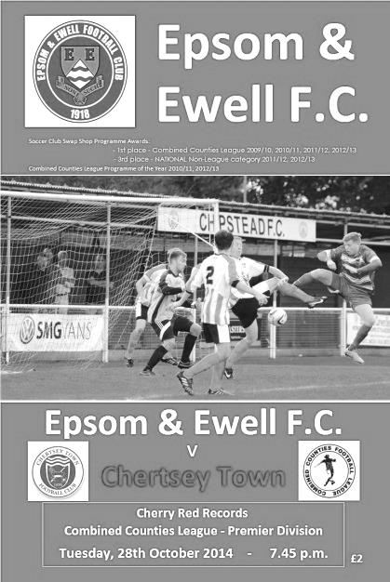
So there we have it. Plenty of matches and if I’m honest, not that many happy memories but you could argue that this makes the good times even more memorable when they happen!

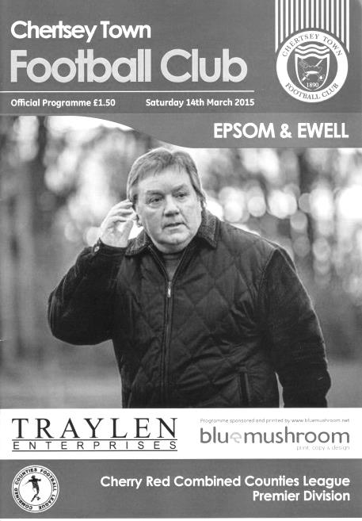

Congratulations Dan!
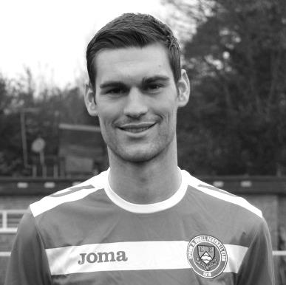
Congratulations go to club Vice-Captain Dan Dean, who made his 50th appearance in our League Cup tie at Banstead Athletic.

Dan joined us from Chipstead last season and has proven to be quite a versatile player. In fact, the only thing missing from his account is a goal. If it is any help, Sam Currie scored on his 51st appearance for the club, so maybe today, Deano?

Dan becomes the 259th player to reach this milestone and as he is only 26, who knows how many more he could reach!

Birthday Corner
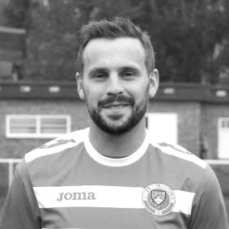
We have three player birthdays in October. Firstly Alex McGregor, who reached the big milestone of thirty just six days ago. Alex has been with us for quite a while now, joining from Bookham back in August 2009 and making his debut on the opening day of the season, along with our Assistant Manager Matt Smith, who isn’t quite thirty yet!

Since then Alex has joined the club Hall of Fame and is currently in 26th position with 236 appearances. He now has 29 goals to his credit and as far as I can tell holds a record for the greatest percentage of goals scored from outside the box with 14 of his tally being scored from distance. In addition to 178 starts for us, he also holds the record for the number of times he has joined the game from the bench with 58 so is clearly versatile!


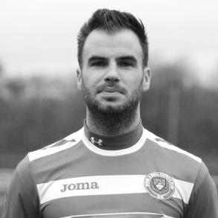
Two of our players share a birthday and on 25th October club Captain Sam Currie will also be 30 with Player / Coach Alex McKay just one year behind him. Both have made well over a hundred appearances for us with Sam on 130 with two goals and Alex on 118 with eight goals. For the latter it has taken some time to reach that figure, as he first joined us back in December 2008. Sam joined us in August 2012, although not many will remember that he also played in a Dave Wilson Trophy match for us against Molesey in 2010. He has been fairly regular since then with exception of a nasty knee injury that developed complications. We hope the injury he picked up on Tuesday will not keep him out for long, although it looked horrible!

Congratulations chaps. Have a good one!

Match and Ball Sponsorships – 2015/16
Opponent | Date | Match and Match Ball Sponsor
Hoddesdon Town | 18/07/15 | Geoff Dyke
Windsor | 08/08/15 | Club President Stella Lamont
Erith & Belvedere (FAC) | 16/08/15 | Mike Lovett
Raynes Park Vale | 31/08/15 | EEFC Management Committee
Colliers Wood United | 08/09/15 | Bookham Building Shop – www.buildingshop.co.uk
AFC Hayes | 19/09/15 | John Bonner
Farnham Town | 26/09/15 | Ezara and Inaya Beddoe – our youngest supporters!
Chertsey Town | 17/10/15 | Club Media Officer – Richard Lambert
Dorking Wanderers (SSC) | 20/10/15 | Tony Ferdinando
Chessington & Hook United | 07/11/15
Hanworth Villa | 21/11/15
Guildford City | 05/12/15
Cove | 08/12/15
Sutton Common Rovers | 19/12/15
Redhill | 02/01/16
Spelthorne Sports | 16/01/16
Hartley Wintney | 30/01/16
Bedfont Sports | 13/02/16
Horley Town | 27/02/16
Knaphill | 12/03/16
Westfield | 26/03/16
Badshot Lea | 09/04/16
Camberley Town | 16/04/16
Ashford Town (Mx) | 30/04/16
Ashford Town (Mx) (LC) | tba
For League, League Cup and Surrey Senior Cup Matches:
Match sponsorship - £40.00 Match ball sponsorship - £25.00. Combined £55.00.
For F.A. Cup and F.A. Vase matches:
Match sponsorship - £50.00 Match ball sponsorship - £30.00. Combined £65.00.

Sponsorship includes: (x2 for match, x3 for match and ball)

Admission, programmes, hospitality and advertising and mascot for the day (if required).
If you are interested, just speak to a Committee Member, or drop me an email at: richard.c.lambert@gmail.com


We also thank our Kit Sponsors INTERCEM

Player Sponsorship
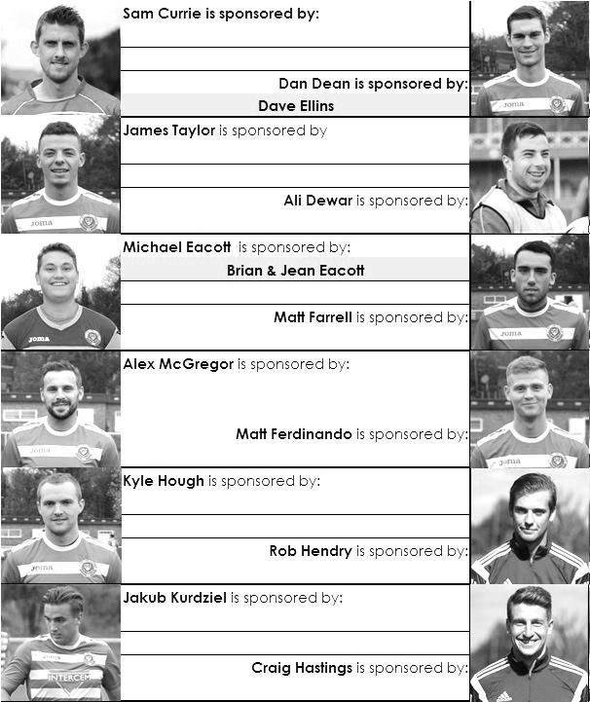

Here is the updated list for the 2015/16 season showing all of our players and Management that are currently available for sponsorship this season.

Sponsorship costs just £40 and it is easy to do. Just select a player who has not been previously sponsored and let a Committee Member know that you would like to sponsor them. Beware though. Until we have received the money it is possible for someone to jump in front of you, so don’t delay, sponsor today!

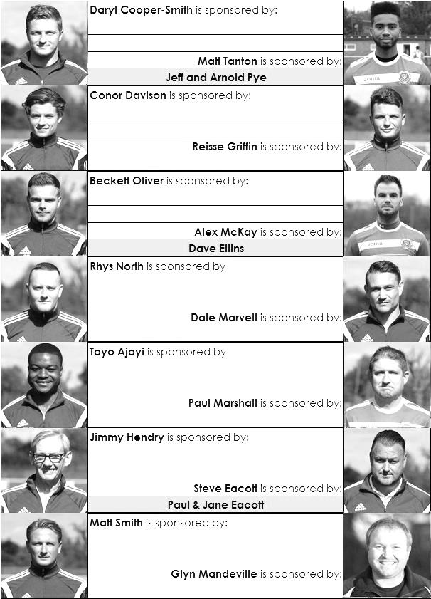

Latest Results Grid
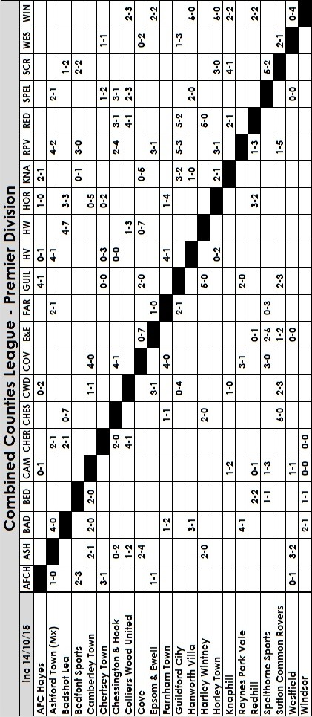

Salts Super Six Predictor
The Salts Super Six Predictor Competition is live again and the tickets are on sale at today’s game to the left of the gate. Six Premier League fixtures are on the list, all of which take place this afternoon.

The competition is easy to play! To win, you simply need to predict the results of six matches correctly from the three options, fill in the form and make sure it is back with our sellers before the deadline on the ticket.

If you are a club regular, you just need to place your name on the sheet, although if you aren’t, then we’ll need a contact number from you too. We will announce any winners on the website within three working days, so don’t worry we won’t miss you!

A 93rd minute West Ham equaliser denied two people a share of the pot last time out, so the jackpot keeps rising and is already up to £254 How much higher will it go?

Please note that if there is more than one winner, the prize pot would be shared between the winners. All you need to do now is have a go, as many times as you like!

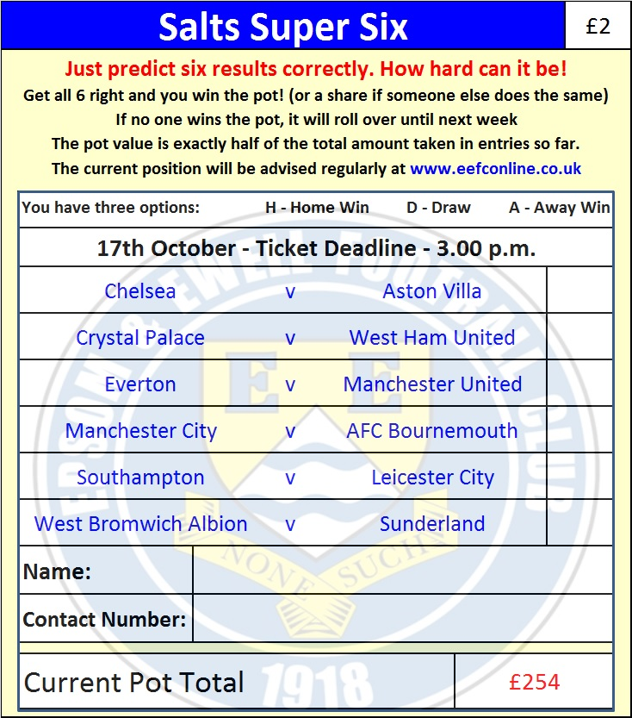

Good luck!

Combined Counties League – Premier Division
Saturday, 17th October 2015 - Kick-off 3.00 p.m.
Epsom and Ewell  (Royal Blue & White hoops) | V |  | Chertsey Town  (All Red)
Squad | NUMBERS
Michael Eacott |  |  | George Armstrong
© Sam Currie |  |  | Danny Alderton
Matt Tanton |  |  | Joe Blendell
Dale Marvell |  |  | Tommy Batten
James Taylor |  |  | Anthony Glover
Dan Dean |  |  | Ben Geraughty
Matt Farrell |  |  | Kieran Woodley
Alex McKay |  |  | Jack Wadmore
Kyle Hough |  |  | John Pomroy
Daryl Cooper-Smith |  |  | Joe Jones
Rob Hendry |  |  | Meddie Nsubuga
Reisse Griffin |  |  | Steve Newman
Conor Davison |  |  | Jamie Ross
Jakub Kurdziel |  |  | Andy Crossley
Rhys North |  |  | Abid Merali
Tayo Ajayi |  |  | Joel Thompson
Matt Ferdinando |  |  | James Cartwright
Craig Hastings |  |  | Bobby Aspinall
Beckett Oliver |  |  | Daniel Alderton
Alex McGregor |  |  | Ross Cull
David Neill |  |  | Ben Heaton
Glyn Mandeville | MANAGER |  | Kim Harris
Matt Smith | ASSISTANT
Steve Eacott / Alex McKay / Jimmy Hendry | COACHES / PHYSIO |  | Dan Dullaway
REFEREE: C.Vick (S.W. London)
ASSISTANTS: M.Ford (Sutton), J.O’Malley (Wallington)
Today’s Match and Match Ball are sponsored by
Club Media Officer and Programme Editor, Richard Lambert

OUR NEXT VISITORS TO HIGH ROAD
Dorking Wanderers
Tuesday 20th October 2015 - Kick-off 7.45 p.m.
Surrey Senior Cup – First Round

